**Chapter 4 – Design and Development Phase**

The Design stage of a project is a phase in which the design of the Graphical User Interface (GUI) for a smooth User Experience (UX) of the application is conceived, as well as the design of an appropriate Data Storage for the application. During this phase, using a storyboarding process, Screen wireframes are created as Blueprints to allow developers to build the application.

The wireframes are an UX-based view of how the application is going to work and show the logic and flow of the application operations. It is also taken into consideration the attractiveness of the app, meaning it is important to mix the design in terms as aesthetics to the functionality of the application. In a real word situation, this phase is made according with the client, so all aspects are in accordance before they move on to the next phase which is the development.

After all the wireframes have been provided, the app can actually be built, this is called the Development phase of a project. In the Agile methodology such as the once being used in this project, the coding process is done as development sprints, which breaks the development up into periods and each period is focused on a different bit of functionality. Once all these sprints are complete, the project goes to the UAT (User Acceptance Testing) version, the client can test it and sign off on. By the end of this phase, the client should have the product developed with all the specification and the whole source code for the application.

This project also is based on Voice User Interface (VUI) which involves the communication with a smart home device, in this case Google Home. The user is able to do the search of a desired pet through voice control via Google Assistant from Google Home and by doing so, the result of the search will appear on the app without the need of clicking through buttons. The platform used to develop the VUI is the Dialog flow which will be described ahead at the end of this chapter.

The proposed mobile app starts with a Splash Screen emphasizing the logo of the project. The splash screen or start screen or start up screen is defined by Techopedia (2016) as a specific screen to be displayed while the application is still loading. Once it is loaded, the User will be directed to the main application screen (*Home* Screen).

**4.1 Screen 1: *Home* Screen**

When the user opens-up the application, the first screen they see is the *Home* Screen, which has two clickable links: the first one is intended for a user that has already been registered within the *Pawdopter* application (the potential adopter has already created a user profile and recorded in the app’s database). The second button, is for users who are not yet registered within the application, meaning that they need to Register first, before been properly Logged in (Signed in) the application to use its functionalities. The Wireframe of this screen is presented on Figure 4.1a.

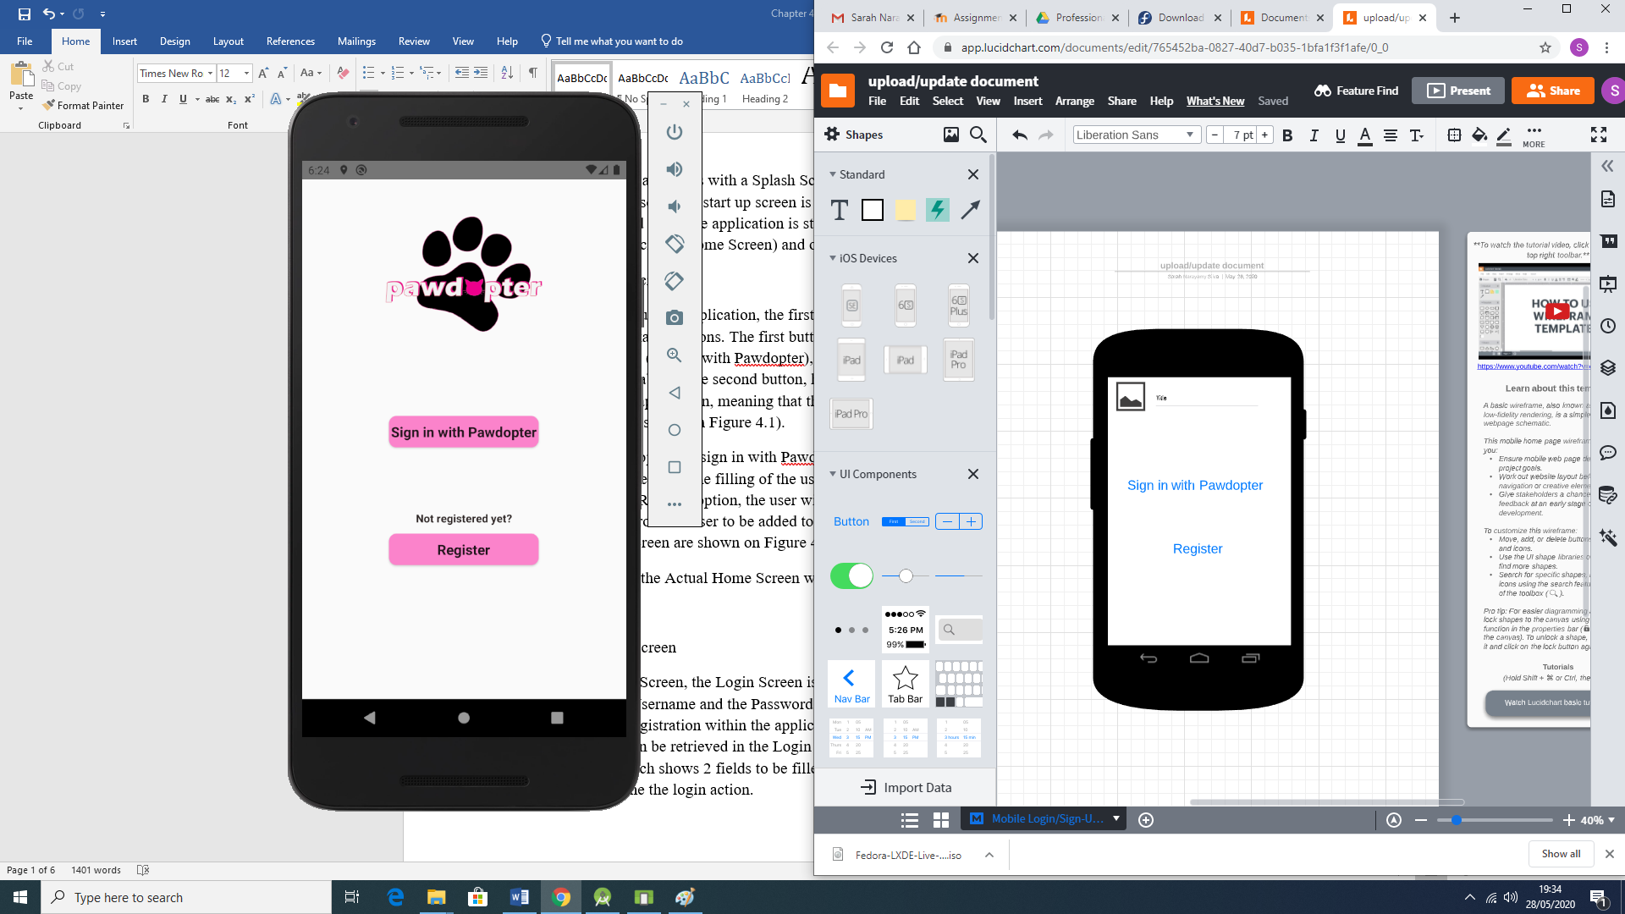

Figure 4.1a: Wireframe for Application Screen 1: Home

Clicking on the option to *Sign in with Pawdopter*, the potential adopter is redirected to a *Login* Screen, which requires typing of username and password, as provided at registration point. Clicking on the *Register* option, the user will be redirected to a *Registration* Screen, which will collect necessary data from the user to create a *user record* in the database. Figure 4.1b shows snippets of code (Java code to the left, and XML code to the right) for the *Home* Screen, while the actual application *Home* Screen is displayed on Figure 4.1c.

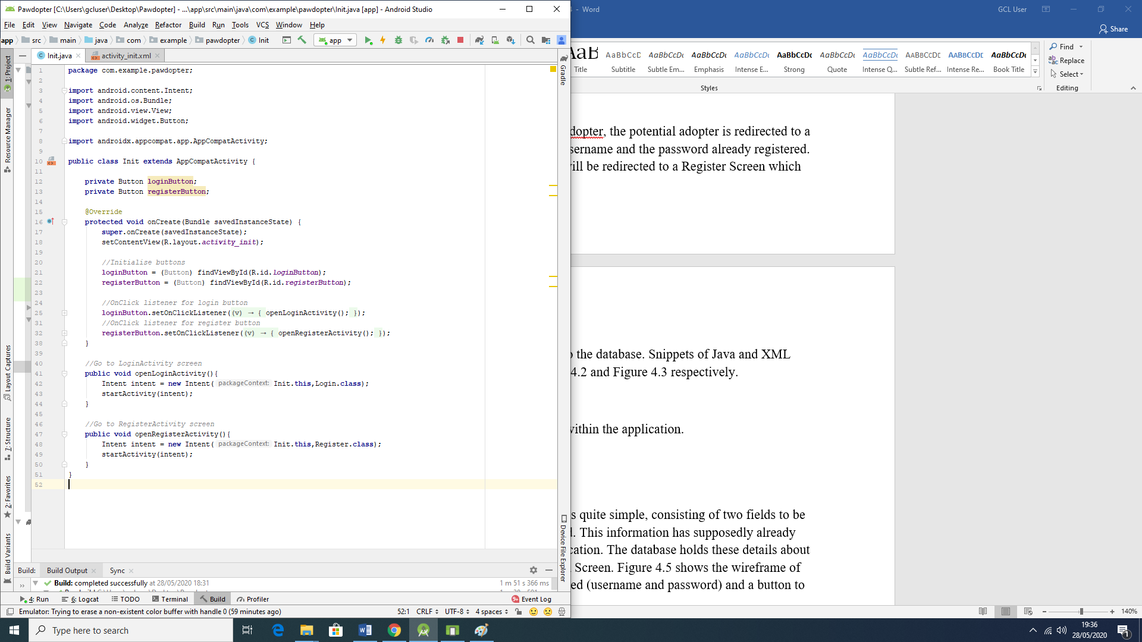 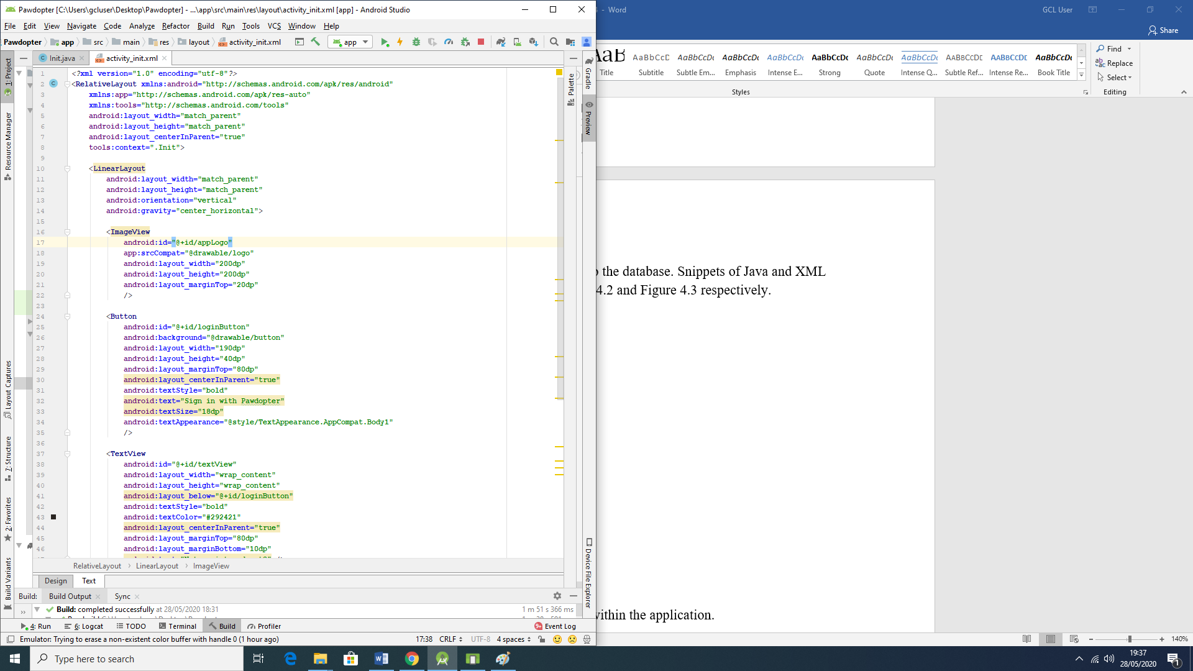

Figure 4.1b: Snippets of Code for Application Screen 1: Home Screen

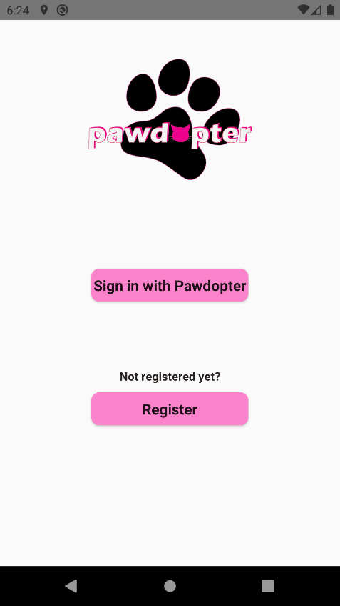

Figure 4.1c: Snapshot of the Actual Application Screen 1: Home Screen

The wireframe and the actual screen differ on where the title and logo of the app appears. In the wireframe the logo is set to be at the top left corner of the screen and the title right beside it, as a pattern for all screens. However, for aesthetics reasons, it was decided to place the *logo*, which already contains the name/title of the app, aligned on top centre of the screen.

**4.2 Screen 2: *Login* Screen**

As with the Home Screen, the Login Screen is quite simple, consisting of two fields to be filled: *Username* and *Password*. This information is to be provided at *Registration* point and placed as user record in the application database. The database holds these details about each user, and they can be retrieved and compared with the captured entries for *Username* and *Password* at *Login* point. Figure 4.2a shows the wireframe of the *Login* Screen with the 2 fields to be entered (*username* and *password*) and a button *Login* to be clicked to begin the *Login* process.

Figure 4.2b shows snippets of code (Java code to the left, and XML code to the right) for the *Login* screen, while Figure 4.2c presents the actual application Screen 2: *Login* Screen.

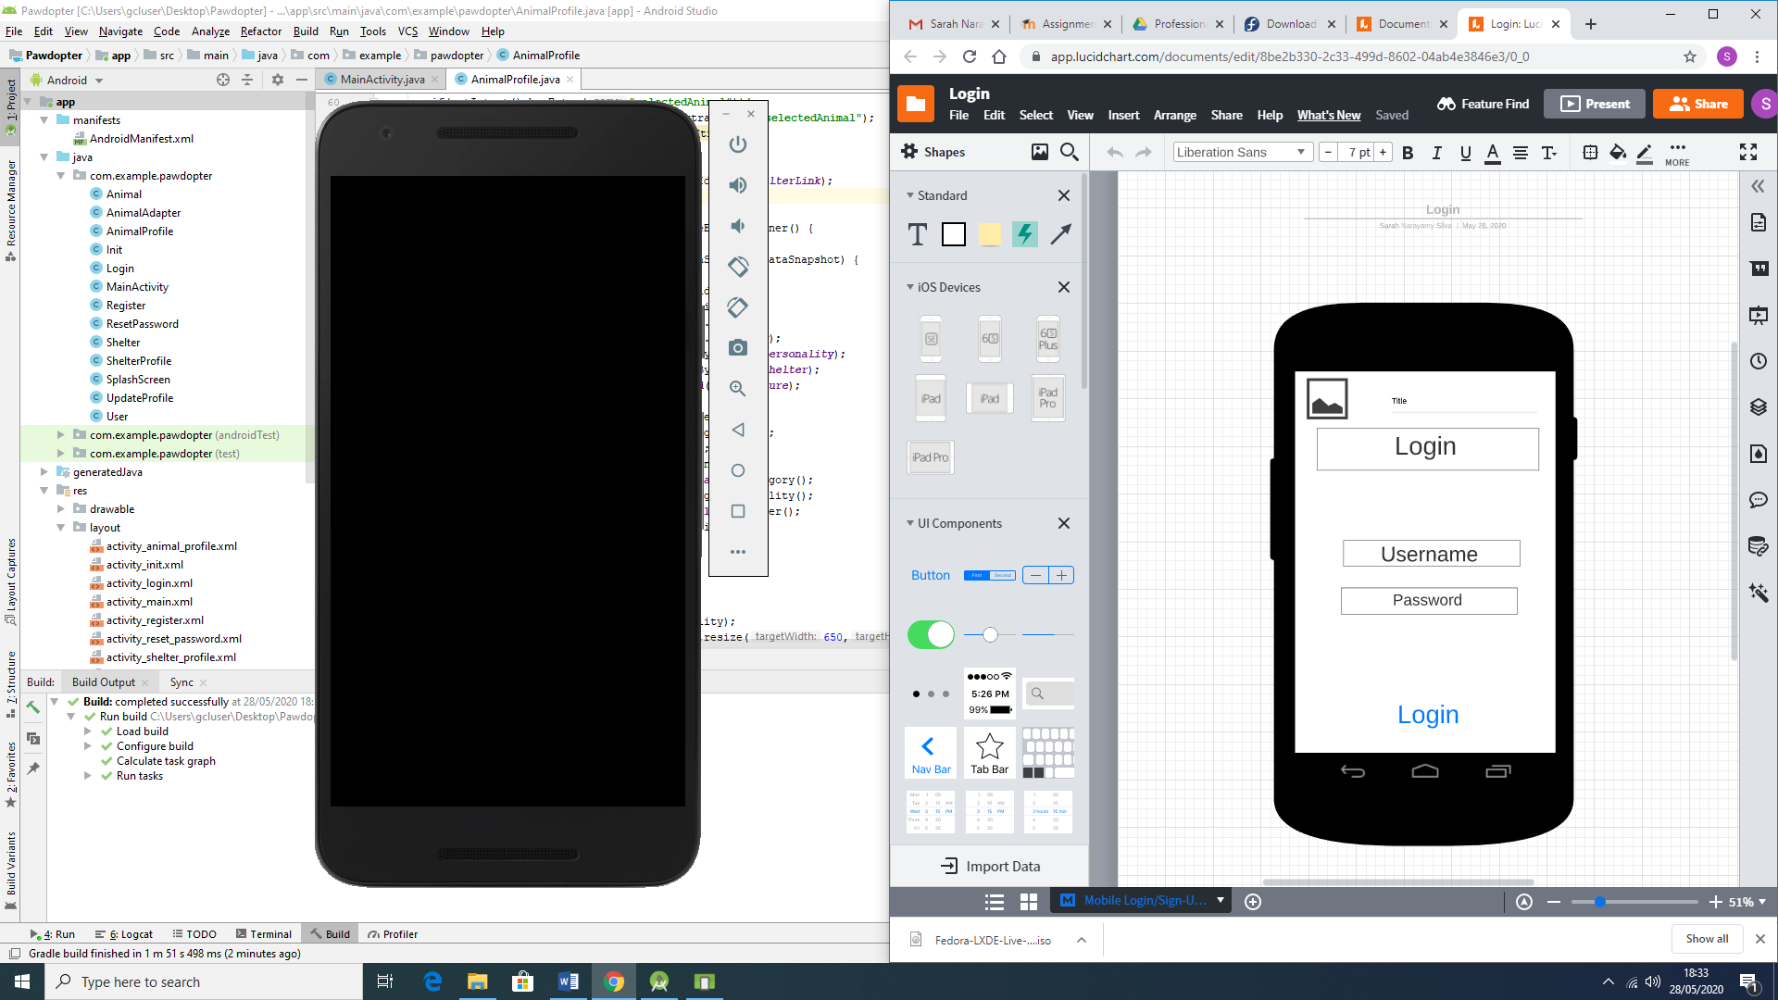

Figure 4.2a: Wireframe for Application Screen 2: Login Screen

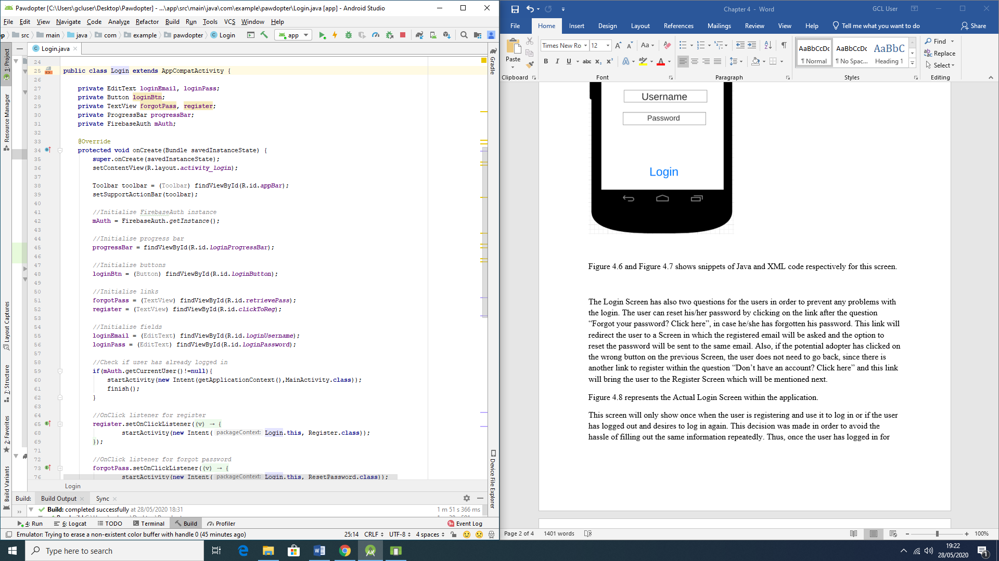 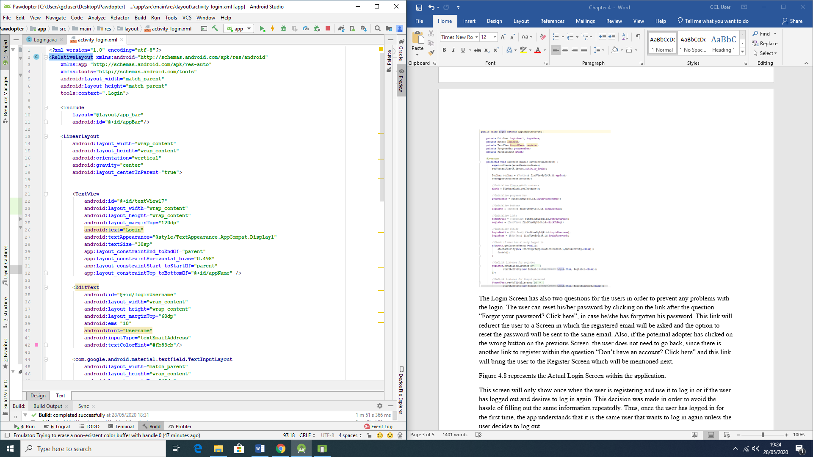

Figure 4.2b: Snippets of Code for Application Screen 2: Login Screen

There are also two links on the *Login* Screen: “*Forgot your password? Click here*” link (in case the user has forgotten their password, they can reset it by clicking on that link, which will redirect the user to a Screen where they need to type their registered email address and a *reset password* link will be sent to that same email), and “*Don’t have an account? Click here*” link (if the potential adopter has clicked on a wrong link at the previous Screen, this link will bring the user to the *Registration* Screen to properly register with the application).

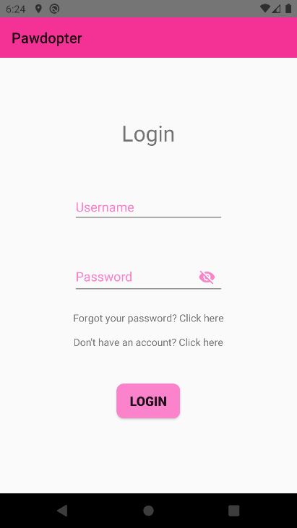

Figure 4.2c: Snapshot of the Actual Application Screen 2: Login Screen

As with the Home Screen, the wireframe of the *Login* Screen and the actual application screen differ where the title and logo of the app should be, and as explained for the previous screen, due to aesthetics reasons, it was decided to display only the title of app on the top left corner. There are also the added links in case of *forgotten password* and for *registration* (*creating an account*), without having to go back to the previous screen to do so.

**4.3 Screen 3: *Registration* Screen**

The *Registration* Screen is very important, since it will collect the data needed from the potential adopter, which data will be recorded on the application database. The information to be captured on this screen consists of *Name* of the user (which is needed in order to deal with the user in a direct and respectful way, by using their name, for example, “Welcome Sarah”; *Phone Number*, which is important in order to contact the user, when necessary; *E-mail address*, which could also be used to contact the user but most importantly - to determine the *Username*, once email is unique for each person; *Password* chosen by the user (which should contain mixture of lower case & upper case characters, number(s), and special character(s) and be not less than 8 characters long); *re-entered (confirmed) password*, to allow verification of entered and confirmed password.

The screen has a *Submit* button, which must be clicked after all the fields are entered by the user. It is important to state that all the fields are *mandatory*, which means that the user will not be able to register if one or more fields are blank. There are also different criteria for the fields, in order to validate the information, such as mobile number (which should start with “08” in order to be validated as an Irish number, and should be 10 digit long). The e-mail address should contain the username, the @ symbol and the domain.

Figure 4.3a illustrates the wireframe of the *Registration* Screen, consisting of the fields to be entered by the user and the *Submit* button. Figure 4.3b shows snippets of code for the screen (Java code to the left and XML code to the right), while Figure 4.3c presents snapshot of the actual application Screen 3: Registration Screen.

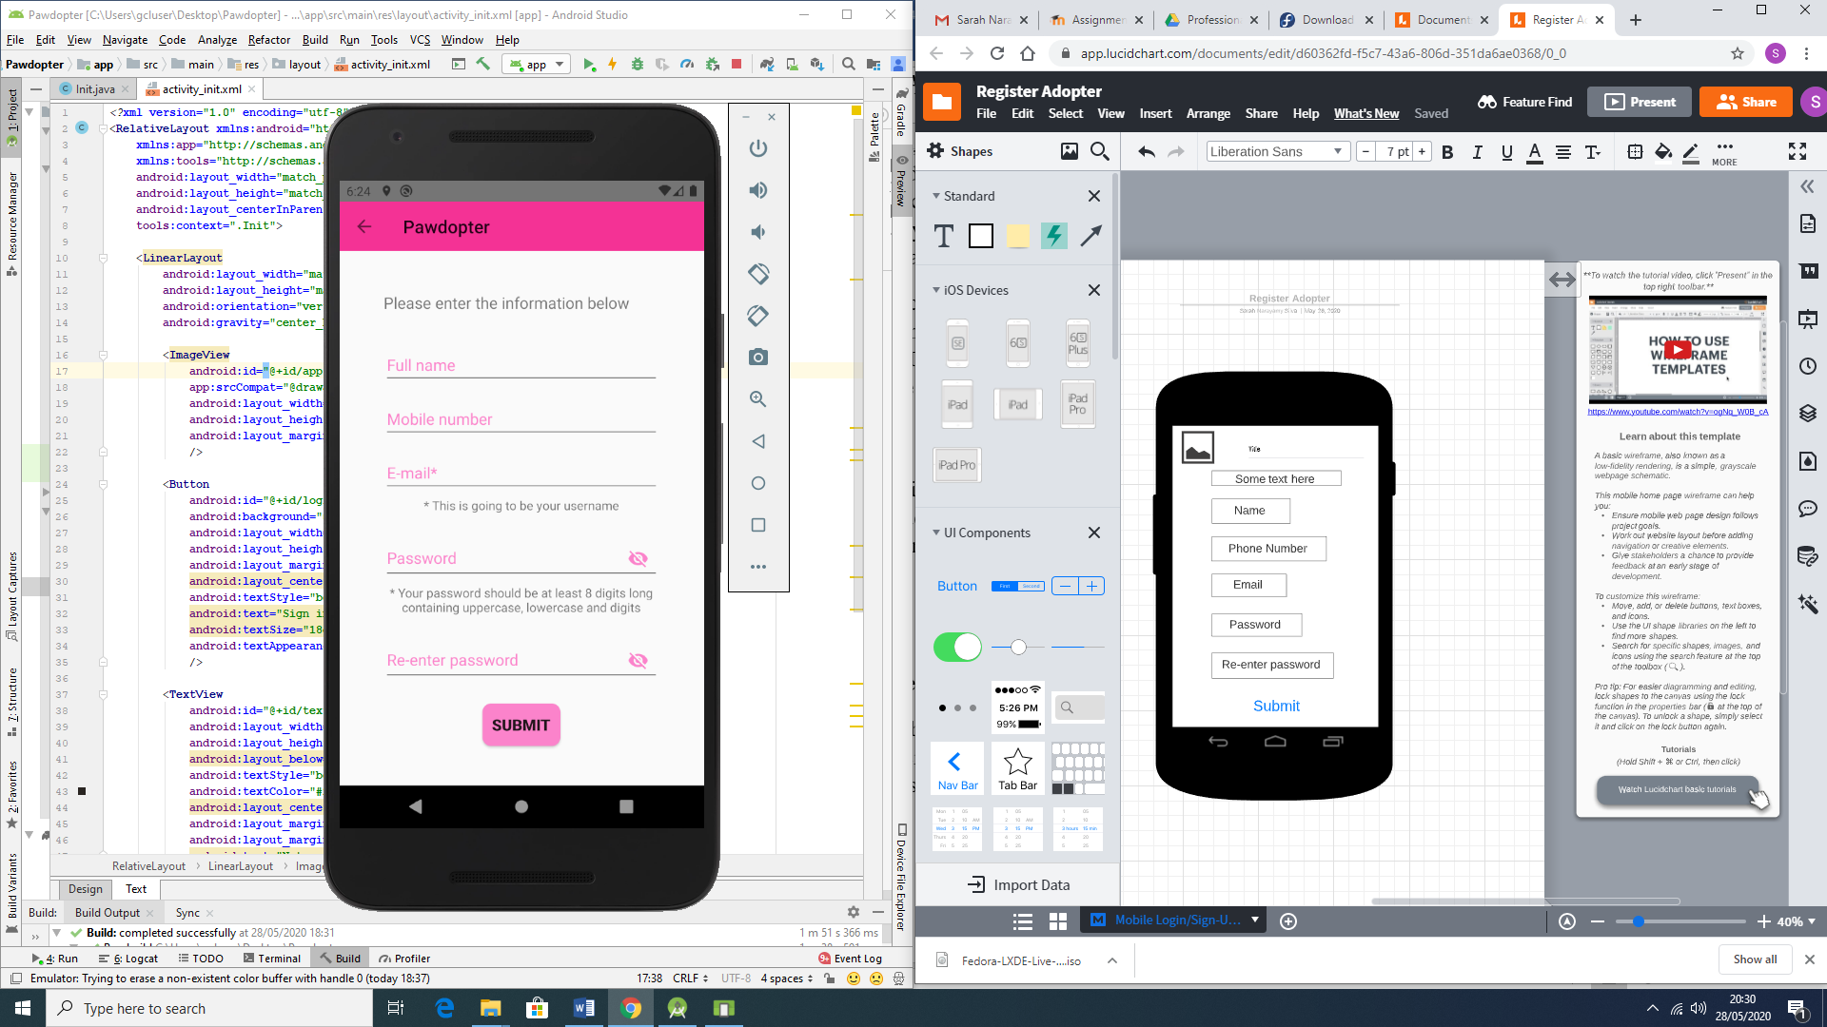

Figure 4.3a: Wireframe for Screen 3: Registration Screen

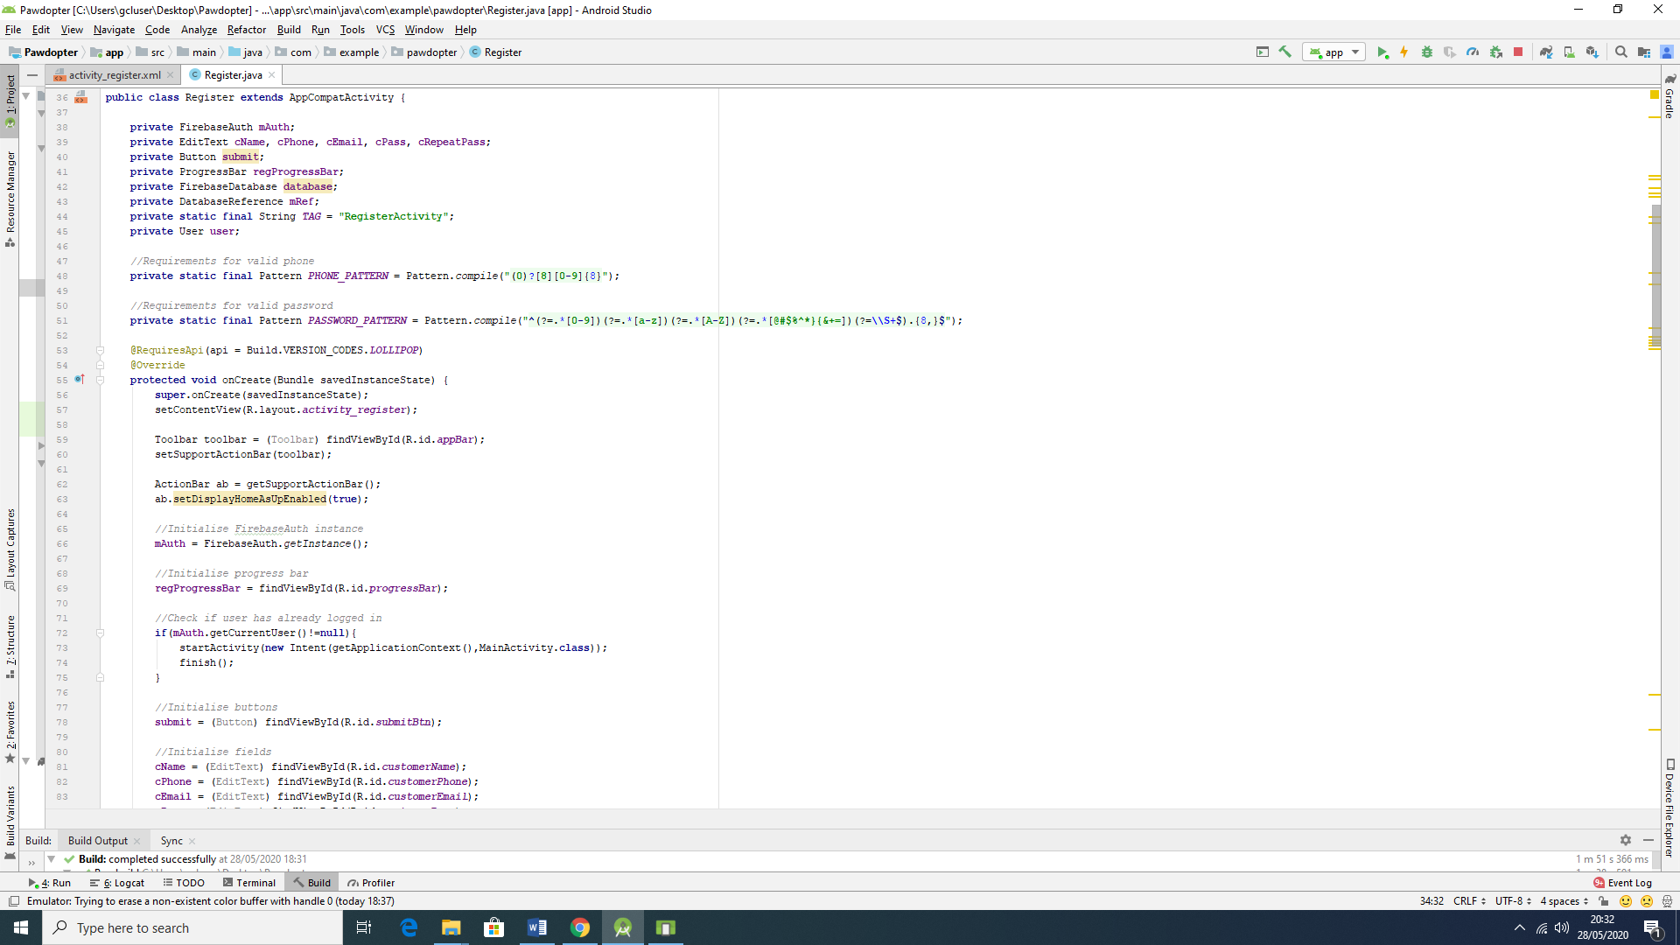 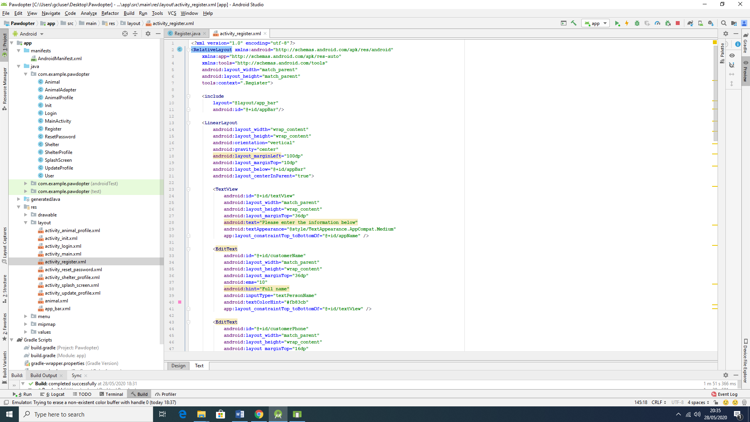

Figure 4.3b: Snippets of Code for Screen 3: Registration Screen

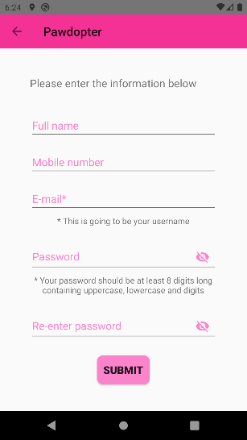

Figure 4.3c: Snapshot of the Actual Application Screen 3: Registration Screen

As with Screen 1 and 2 wireframes before, the wireframe and the actual application *Registration* screen differ on the same aspects mentioned before, related to the *logo* and *title* of the application. On this screen, the *logo* is replaced with an *arrow* pointing to the left (which implies that the user can go back to the previous screen), followed by the *title* of the app.

**4.4 Screen 4: Pets Browsing and Filtering Screen**

On this screen, the user can browse all available for adoption pets, as well as making use of the filters to search for a pet with specific characteristics. The available in the chosen sanctuary animals are each presented with their photograph, name, age, and short description of personality. Each animal entry is clickable, to reveal more detailed information about the chosen pet on another screen, designed specifically to show only that specific pet’s detailed information.

The animals can be filtered by *category* (choosing what type of animal is desired (dog, cat, etc.)), followed by *size* (small, medium or large animal), and lastly - by *breed,* (as per stored breeds of available animals in the app’s database). It is important to emphasize that these filters are nested and dependent on each other. Once the filtering is done by the user, the *Browse* screen will only show pets that correspond to the filter(s) characteristics, specified by the user.

Another important aspect of this screen is that it provides a menu for the user to *Update* their profile or to *Logout*. This menu, once clicked, redirects the user to the different screens respectively and accordingly.

Figure 4.4a illustrates the wireframe for the *Pet Browsing and Filtering* screen. Figure 4.4b presents snippets of code for the screen (Java code to the left, XML code to the right of the figure), while Figure 4.4c displays the actual application Screen 4: *Pet Browsing and Filtering* Screen.

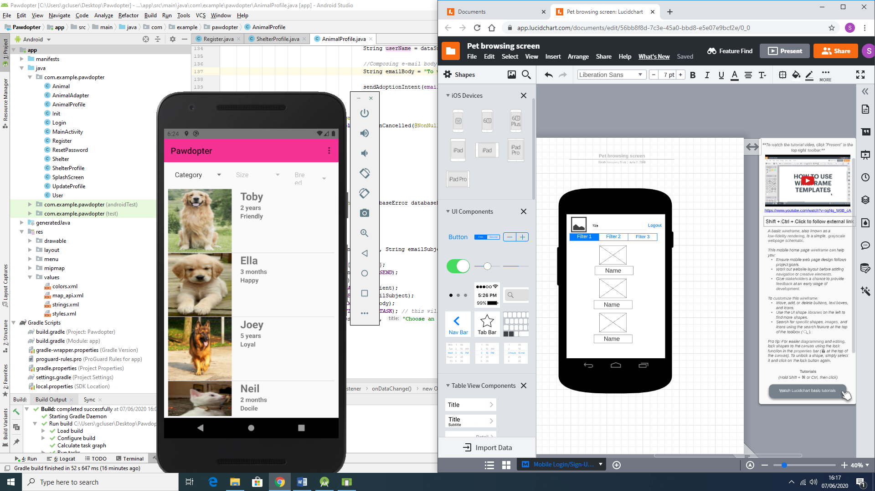

Figure 4.4a: Wireframe for Screen 4: Pet Browsing and Filtering Screen

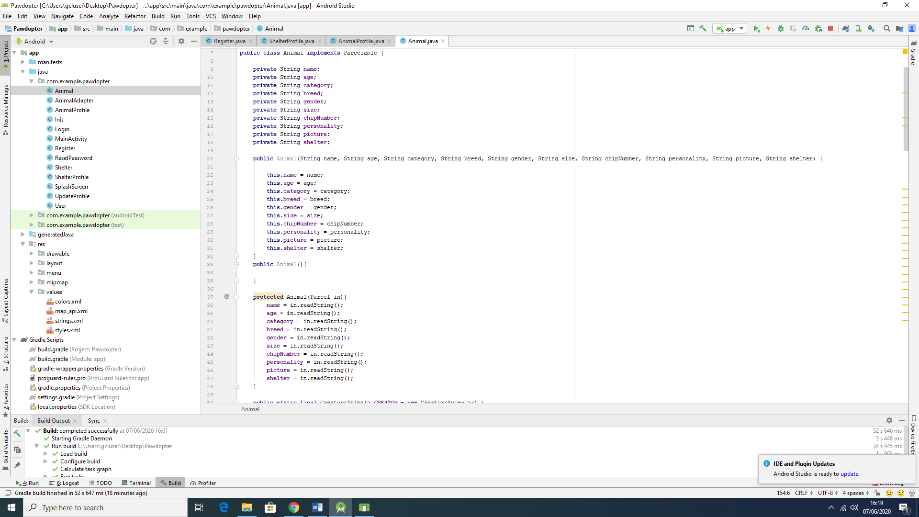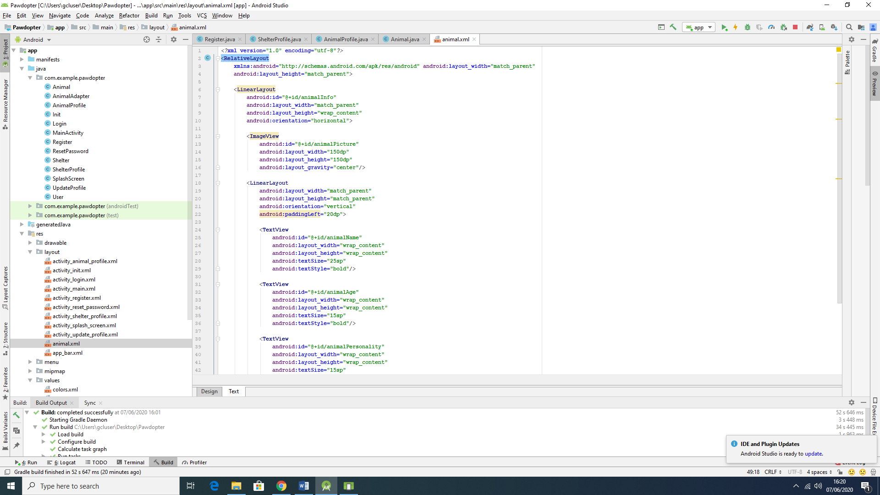

Figure 4.4b: Snippets of Code for Screen 4: Pet Browsing and Filtering Screen

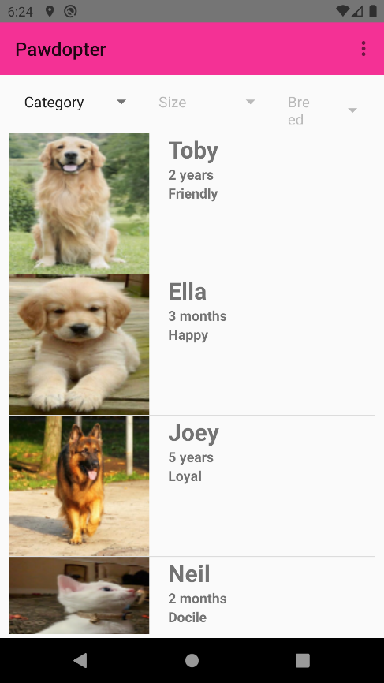

Figure 4.4c: Snapshot of the Actual Application Screen 4: Pet Browsing and Filtering Screen

The filtering is made as shown on Figures 4.9d with snippets of code

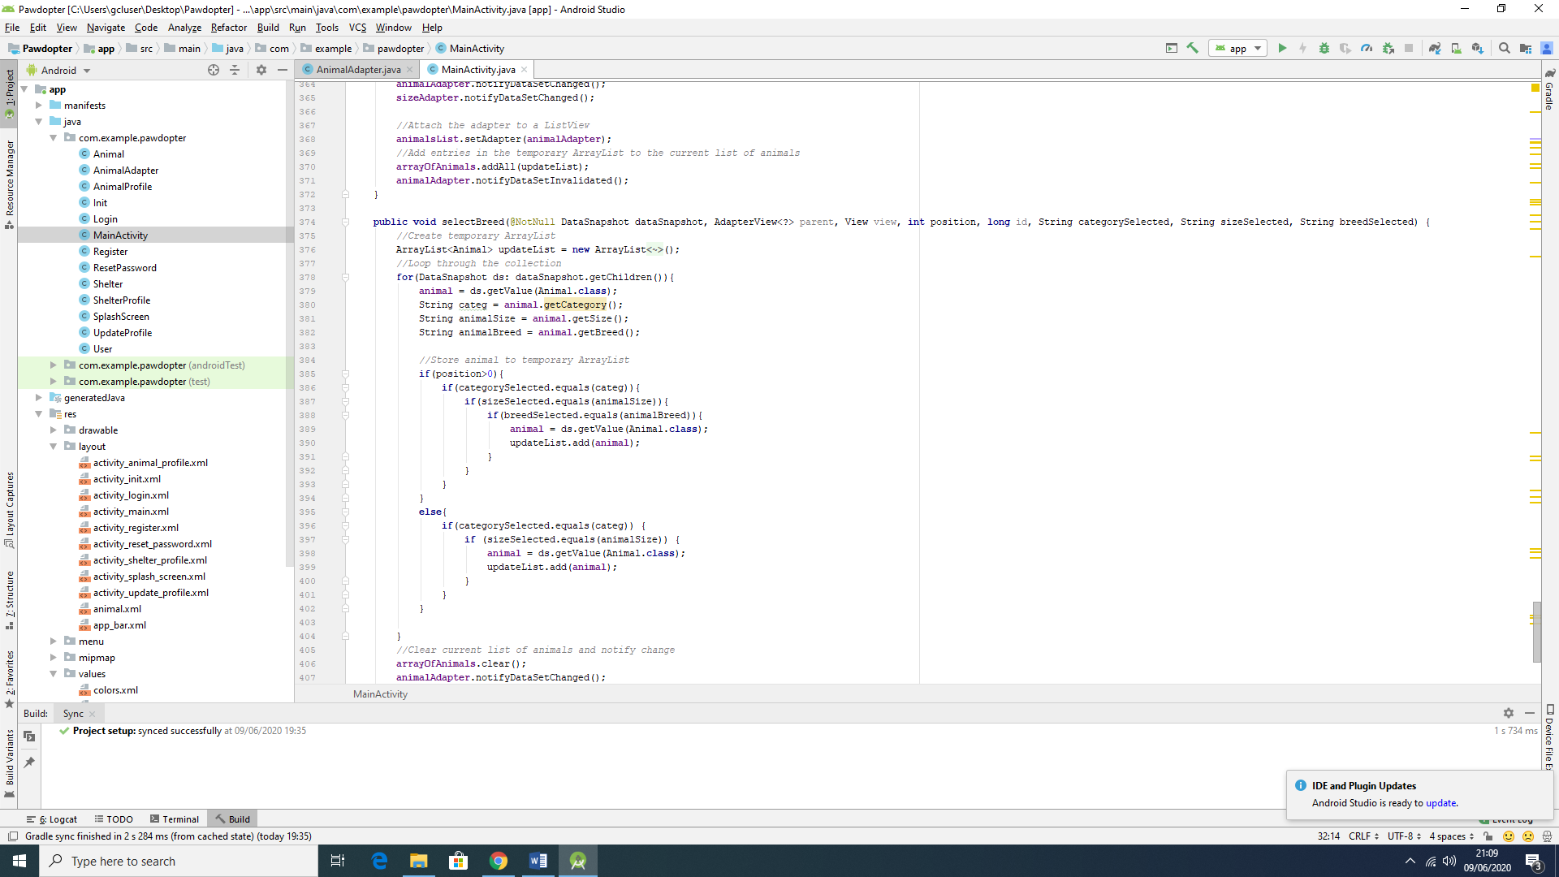

Figure 4.4d: Snippets of code for the filtering process

The wireframe differs from the actual screen in many aspects. It starts by the exclusion of the logo on the top left corner by the replacement of only the name of the application. Followed by the menu mentioned before and represented by the three bullet points in a vertical order. The Filters were kept in the same position from the wireframe, meaning the top of the screen, right after the name and the menu. However, the display of the animals was though to be more informative in the actual application screen, once it shows more information about each pet and they are well divided between each other. In this case, the picture of the animal is positioned on the left corner and 3 information about them is position on the side of the respective picture (Name, Age, Personality).

**4.5 Screen 5: *Update User Profile* Screen**

This screen is similar with the *Registration* screen, except here the user can update its information in some of the entry fields. There are few entry-fields, where information cannot be changed, such as *Name* and *E-mail*, since they are unique to each user. Thus, on this screen, the user can change their contact *mobile number* and the *password*, according to the specifications for each field, as previously mentioned on the *Registration* screen. Once the *Save* button is clicked, all the information changed will be updated in the application’s Firebase real time database.

Figure 4.5a illustrates the wireframe for the *Update User Profile* Screen, Figure 4.5b shows snippets of code (Java code to the left, XML code to the right of the figure) for the screen, while Figure 4.5c displays snapshot of the actual application *Update User Profile* Screen. Figures 4.5d and 4.5e show *before* and *after* the information change has been reflected in database, respectively.

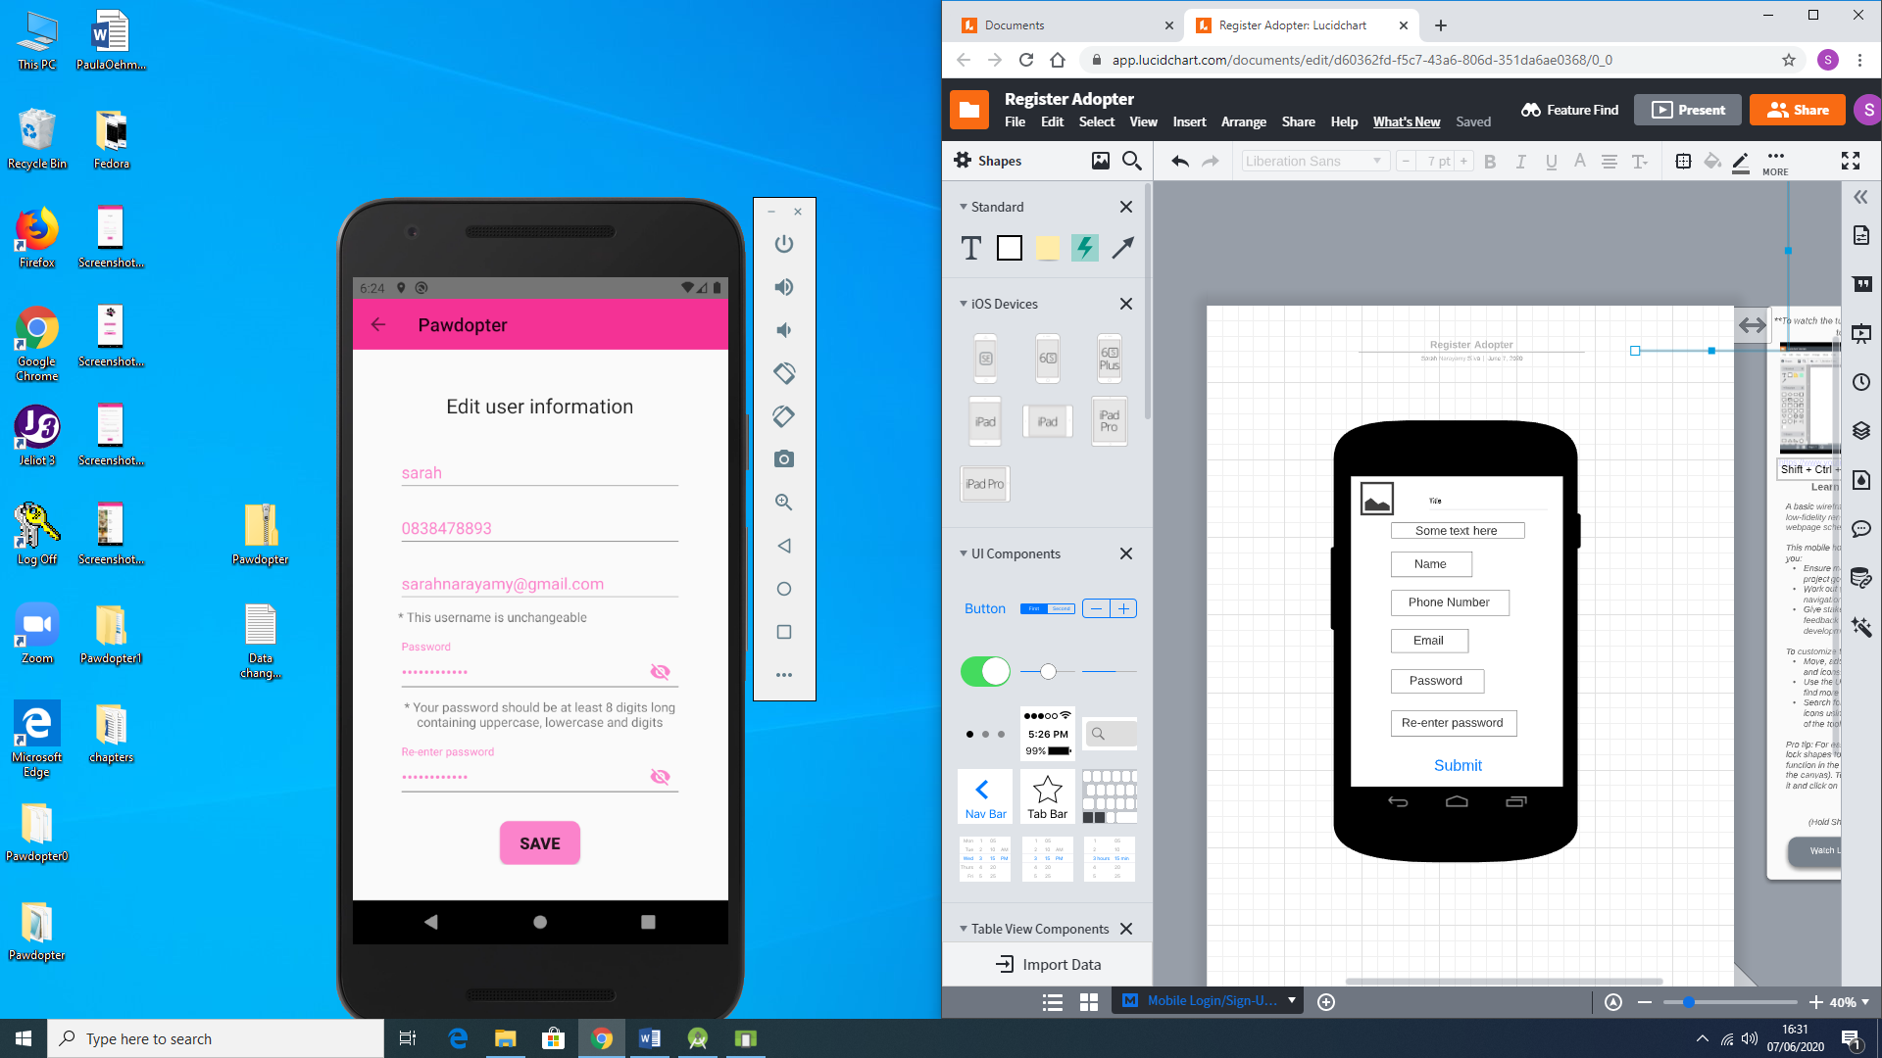

Figure 4.5a: Wireframe for Screen 5: Update User Profile Screen

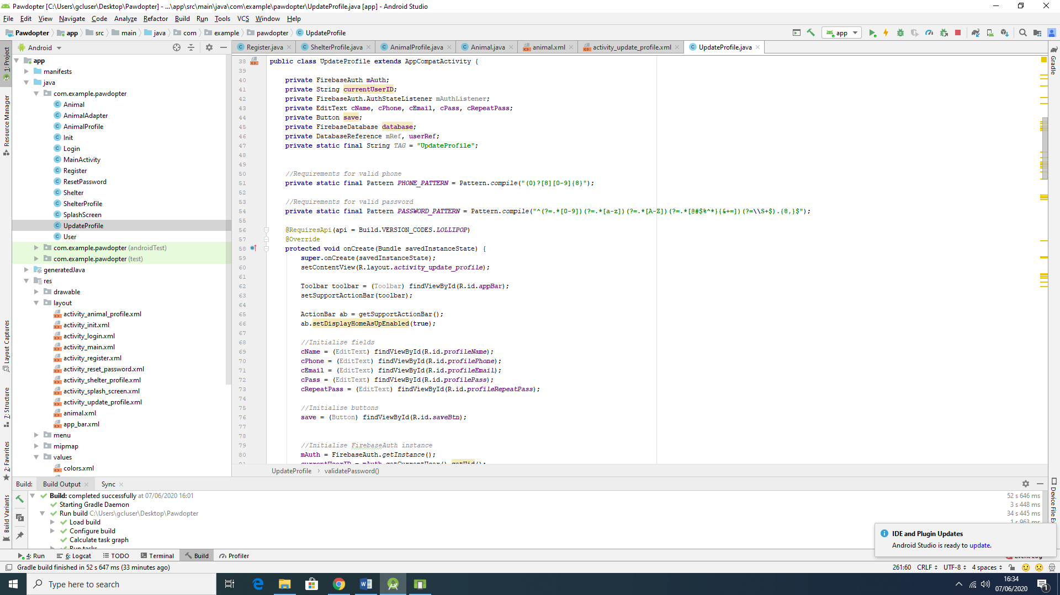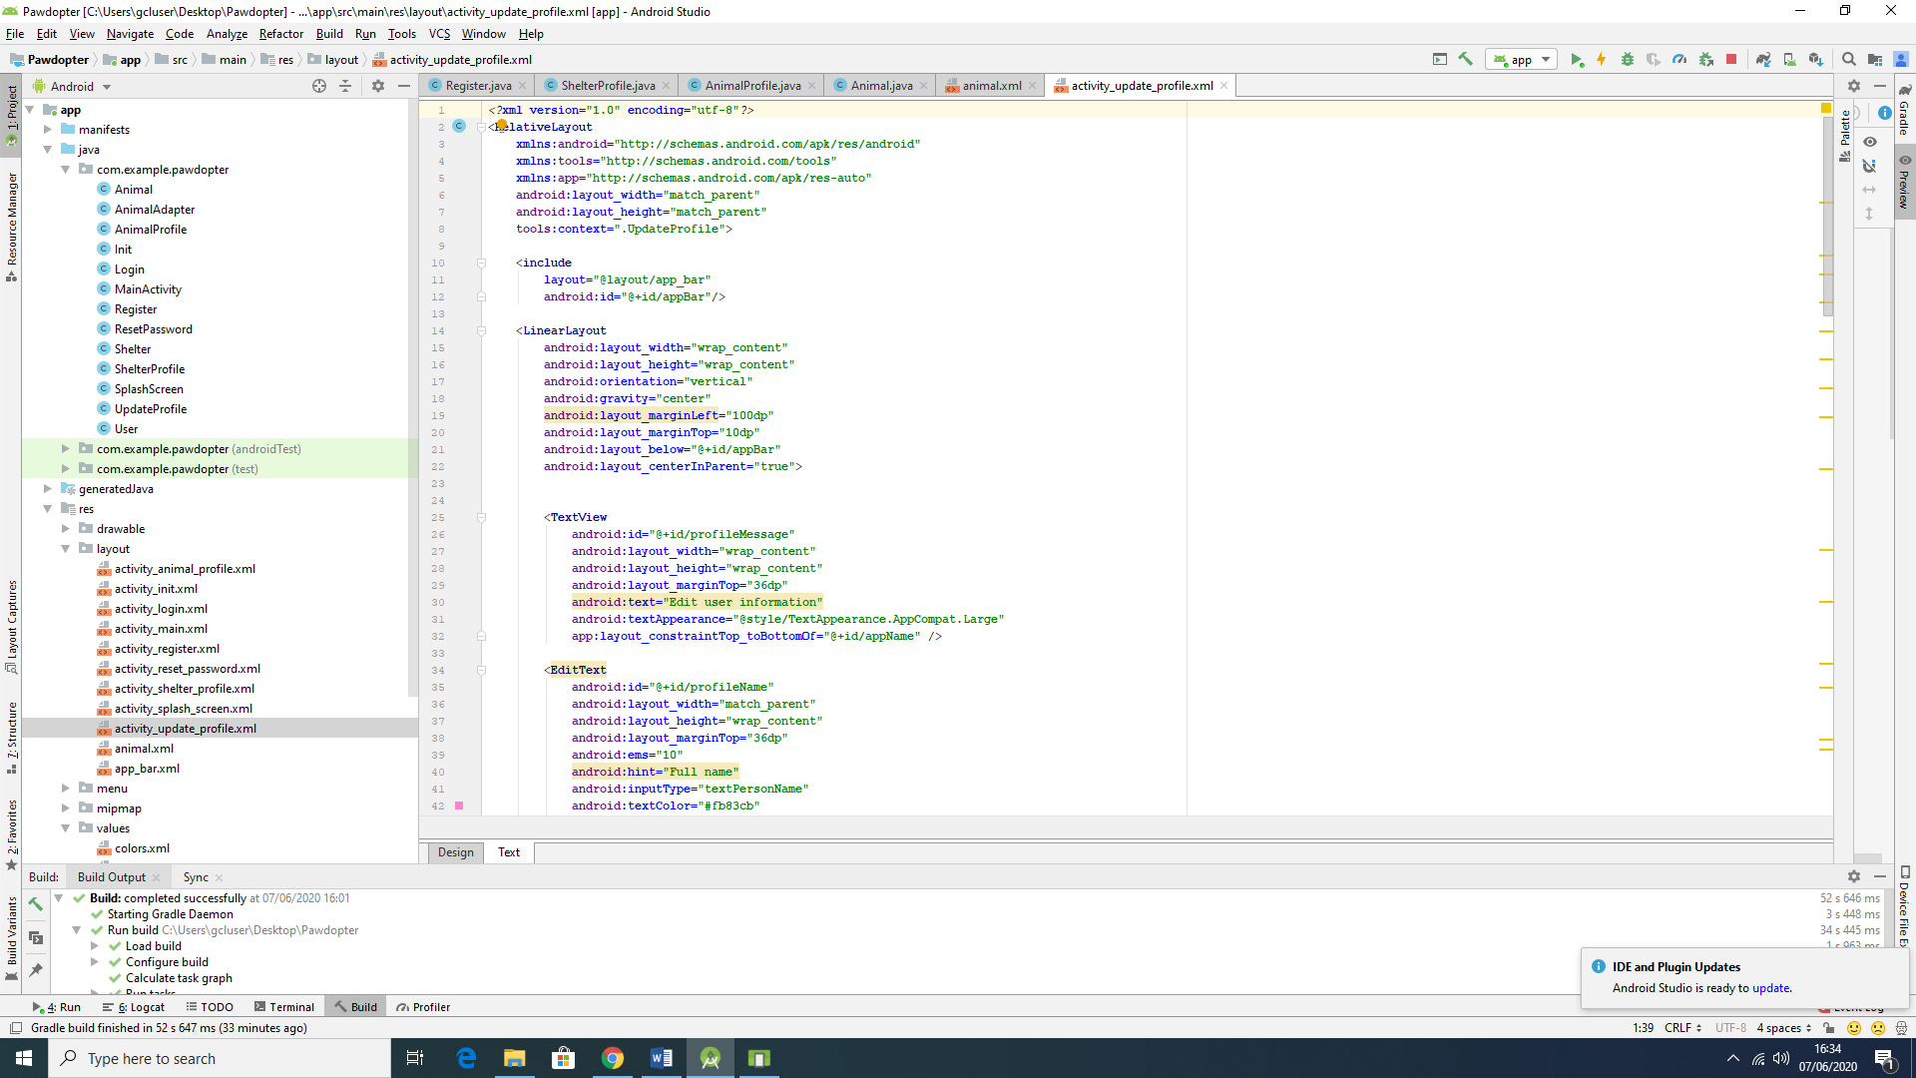

Figure 4.5b: Snippets of Code for Screen 5: Update User Profile Screen

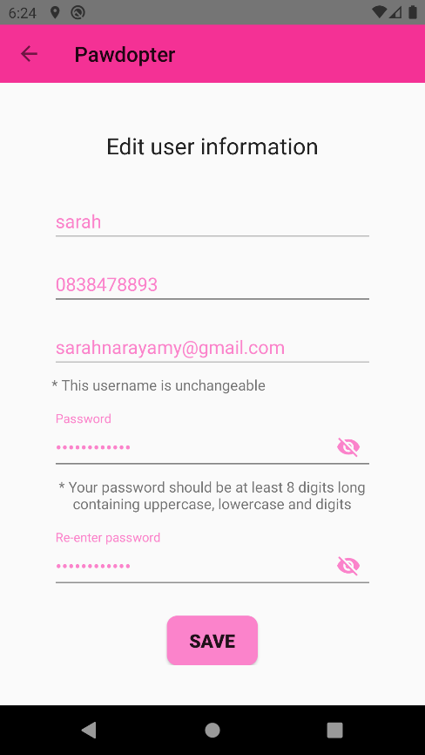

Figure 4.5c: Snapshot of the Actual Application Screen 5: Update User Profile Screen

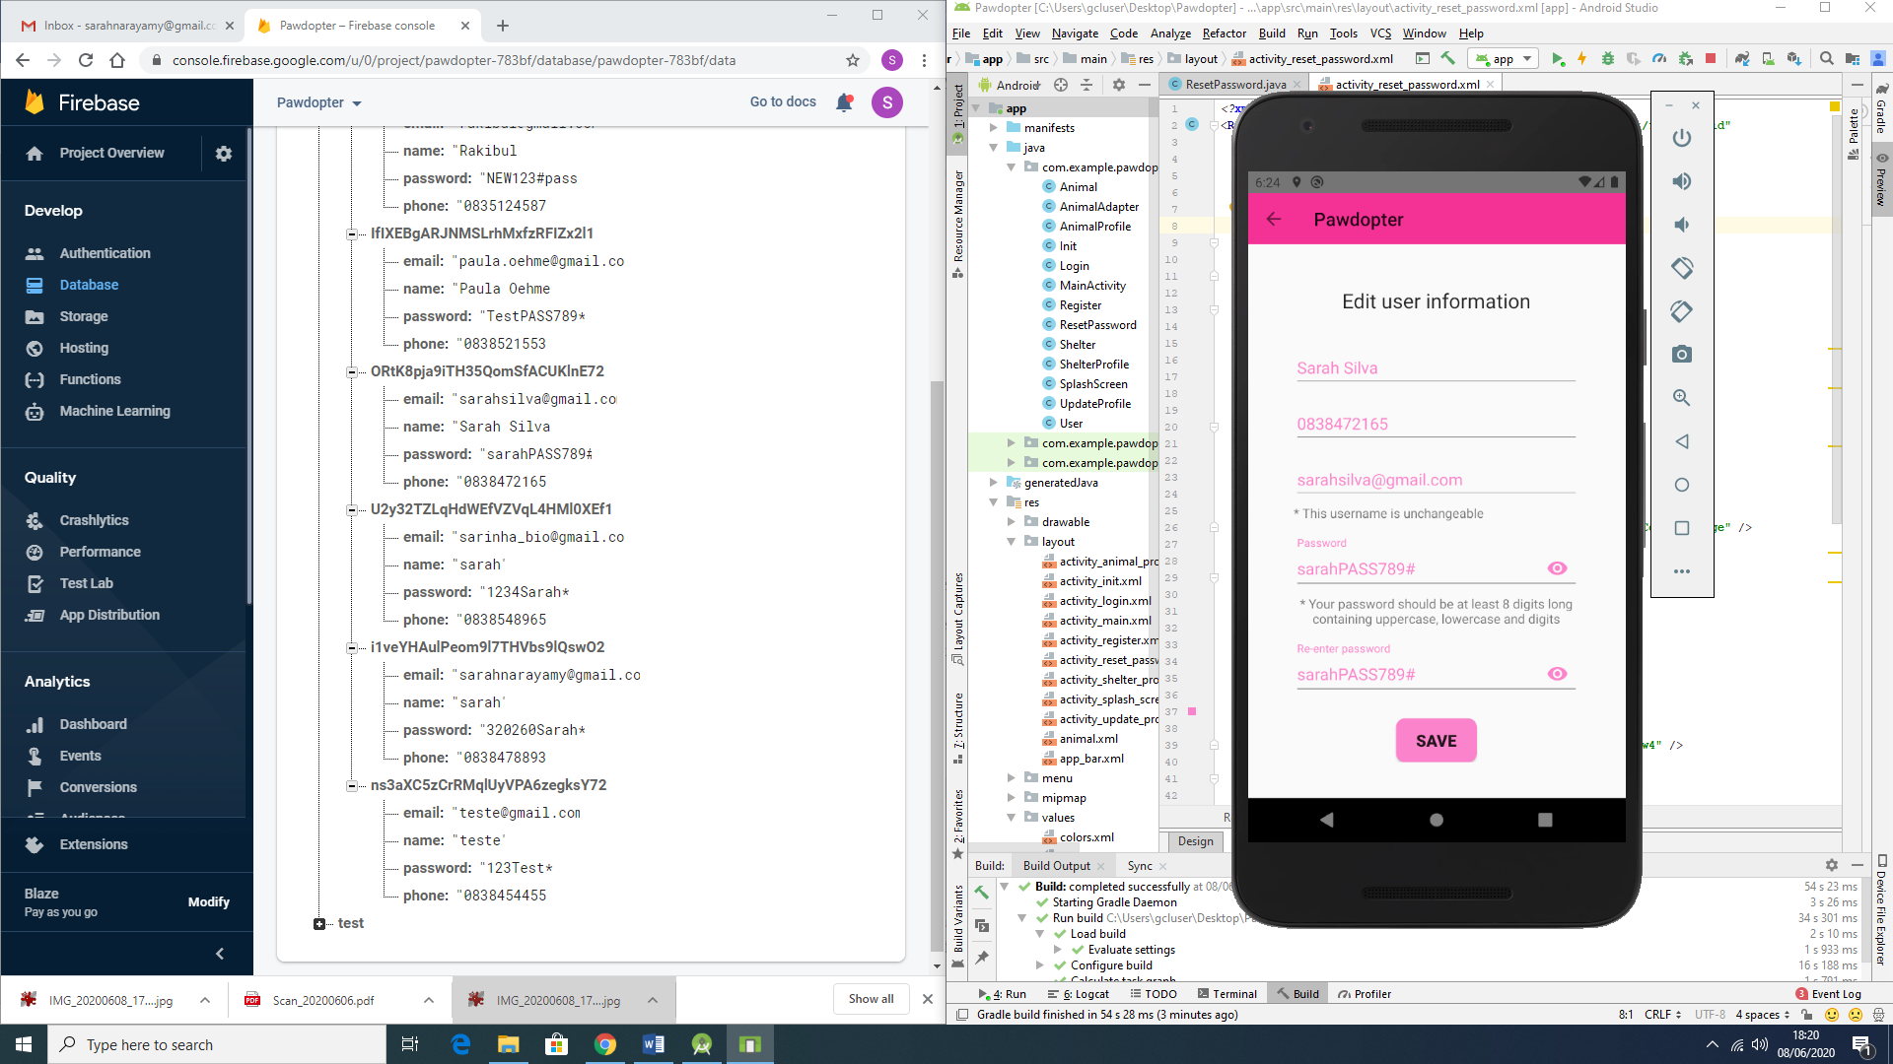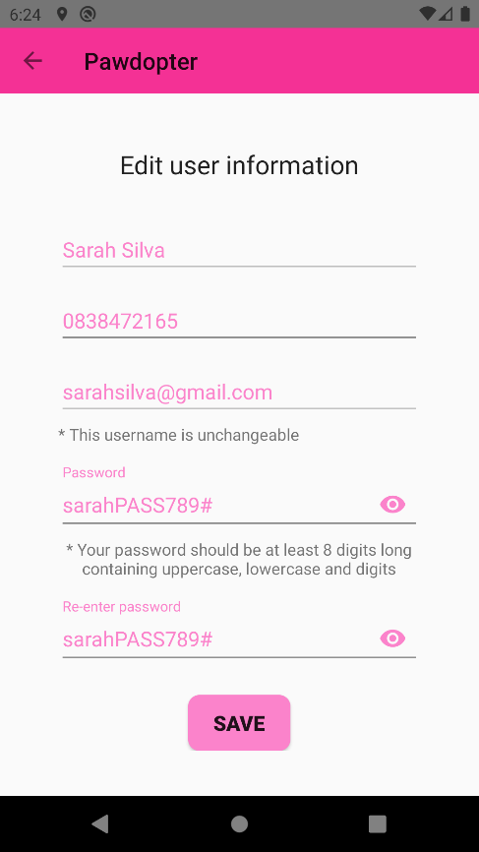

Figure 4.5d: Before the information is changed (Database on the left actual screen on the right)

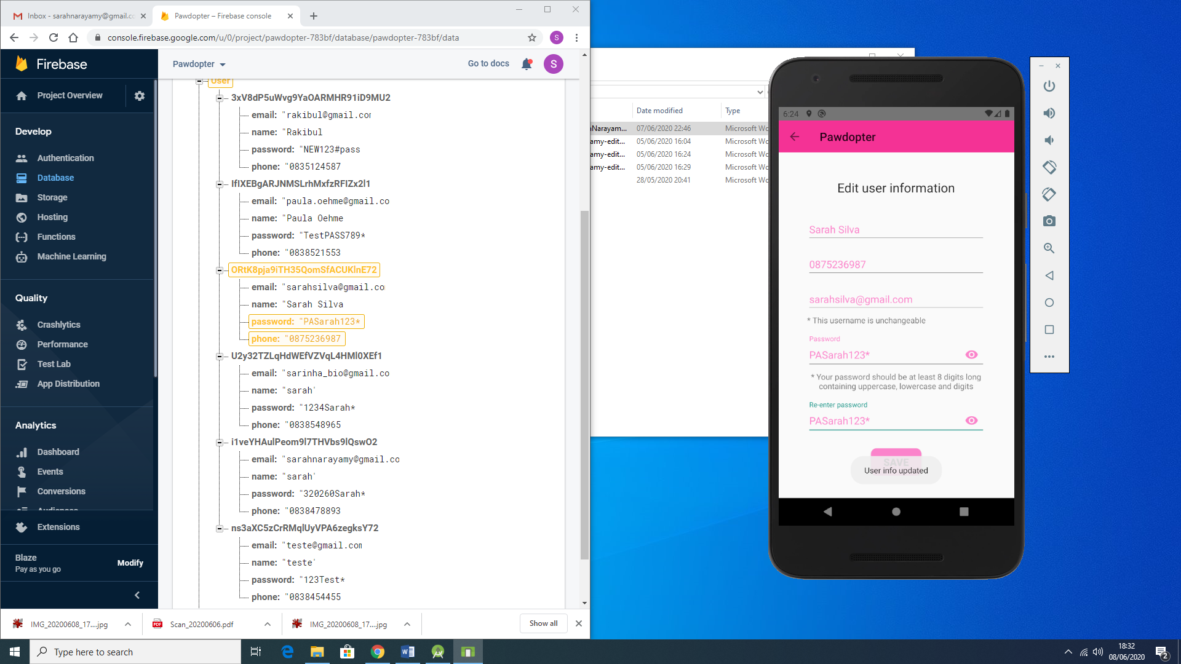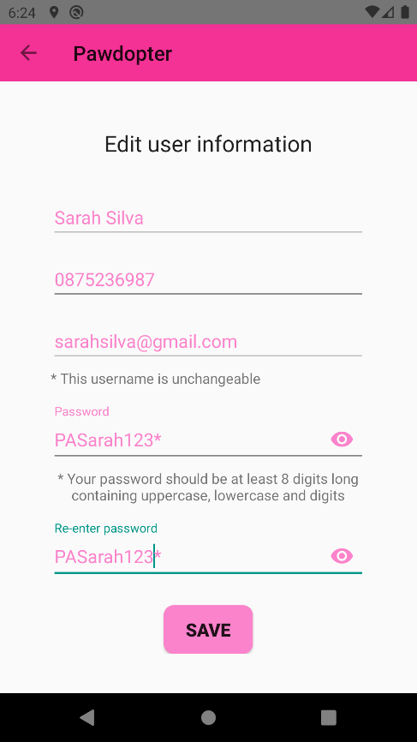

Figure 4.5e: After the information is changed (Database on the left actual screen on the right)

**4.6 Screen 6: *Chosen Pet Visualization* Screen**

When the user clicks on a desired pet from the *Pet Browsing and Filtering* Screen (Screen 4), the user is redirect to a new screen – Chosen Pet Visualization Screen, which provides all detailed information about the chosen animal, such as: picture, name, breed, age, gender, personality and the name of the shelter where this animal is kept.

Figure 4.6a illustrates the wireframe for the *Chosen Pet Visualization* Screen, Figure 4.6b shows snippets of code (Java code to the left, XML code to the right of the figure) for the screen, while Figure 4.6c displays snapshot of the actual application *Update User Profile* Screen.

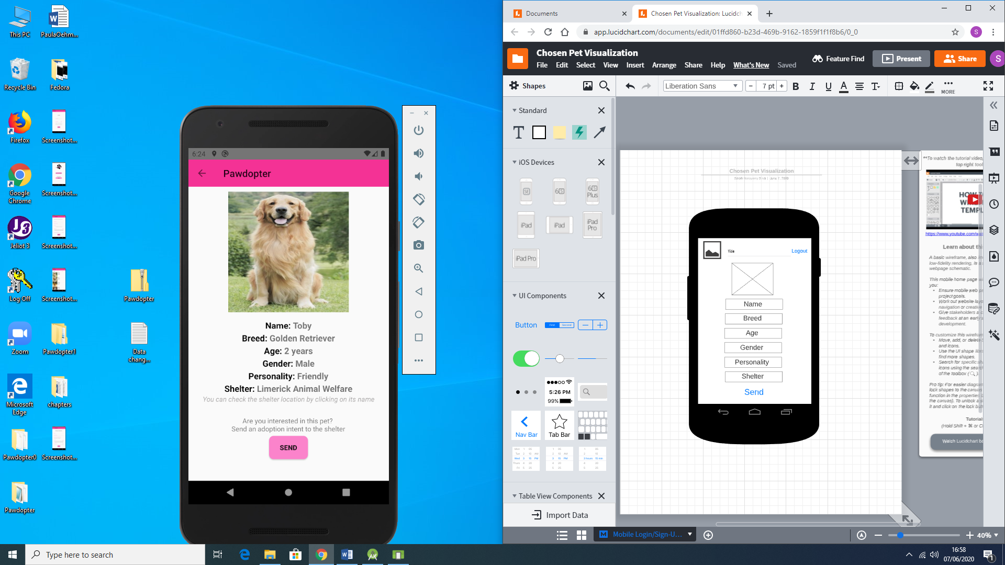

Figure 4.6a: Wireframe for Screen 6: Chosen Pet Visualization Screen

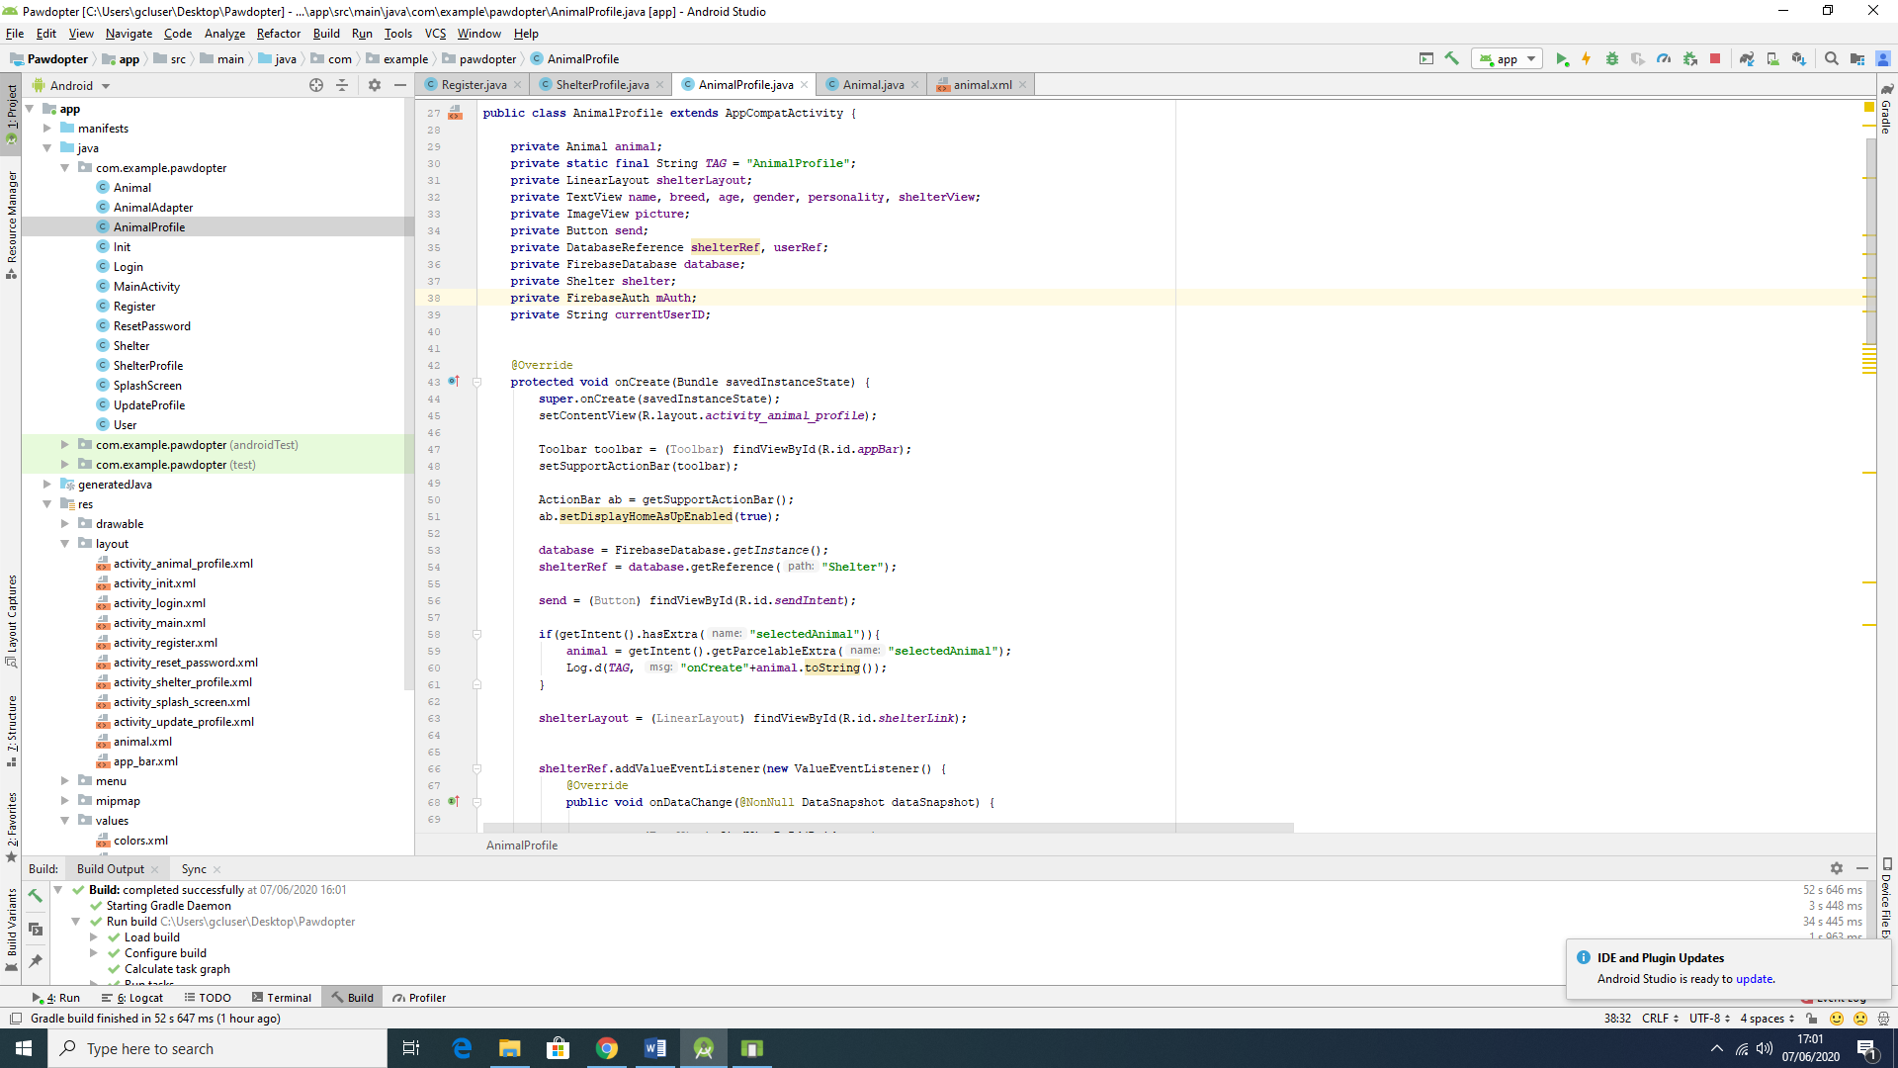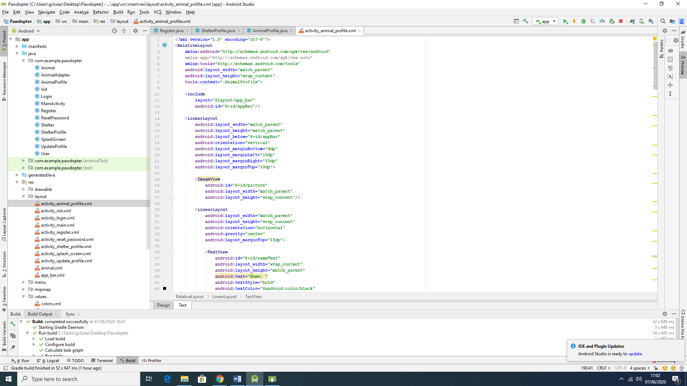

Figure 4.6b: Snippets of Code for Screen 6: Chosen Pet Visualization Screen

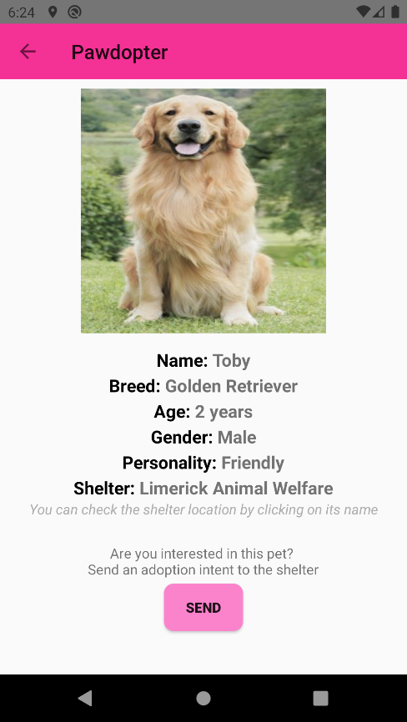

Figure 4.6c: Snapshot of the Actual Application Screen 6: Chosen Pet Visualization Screen

The wireframe and the actual *Chosen Pet Visualization* Screen differ as previously mentioned at the top of the screen by not displaying the logo and using a left arrow instead, which indicates the user can go back to the *Pet Browsing and Filtering* scree. The name of the application is displayed right beside the arrow and at the bottom of the *Chosen Pet Visualization* Screen there is a button which allows the user to send an adoption intent message, in email format, to the corresponding shelter in which the animal is located. Also, in this screen, it was decided to make the name of the shelter clickable so the user can visualize the information on the shelter. By clicking on the shelter’s name, the user will be redirected to another screen which will display the information on the shelter.

When clicked on the send button, the user is asked to select which email platform it is to be used as an email to be sent. Figure 4.6d shows the options (which should vary according to the user’s usage (Gmail, Outlook, Yahoo mail, etc)).

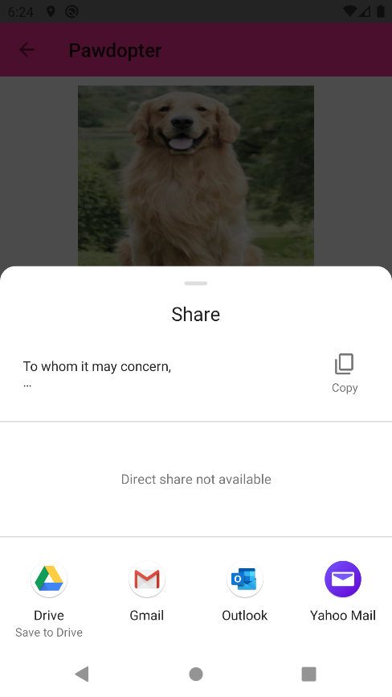

Figure 4.6d: Options to choose to send the intention of adopt form according to the device being used

Once the platform is chosen, a predefined email is already written by the application, which retrieves the information on the user and the chosen animal. The user is able to write and add information on the email as they pleased, however if there is no intention on altering the user should only click on the send button from the email. Figure 4.6e shows the pre-written email. In this case, for security reasons, accordingly to the General Data Protection Act (GDPR), the application only retrieves the email and the name of user, in order just to make a first contact between the user and the shelter, however as mentioned before, the user is capable of adding information such as mobile number or other form of contact as they pleased. Figure 4.6f shows the email sent to the shelter and followed by the email received from the shelter in response with a date and time for visiting the sanctuary.

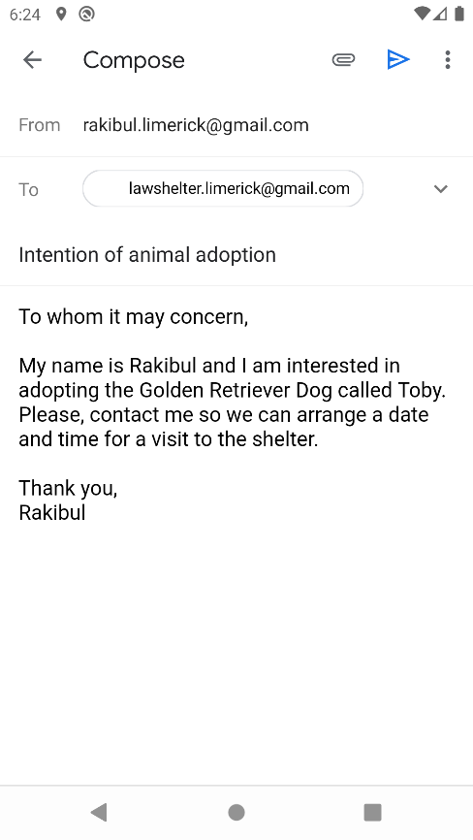 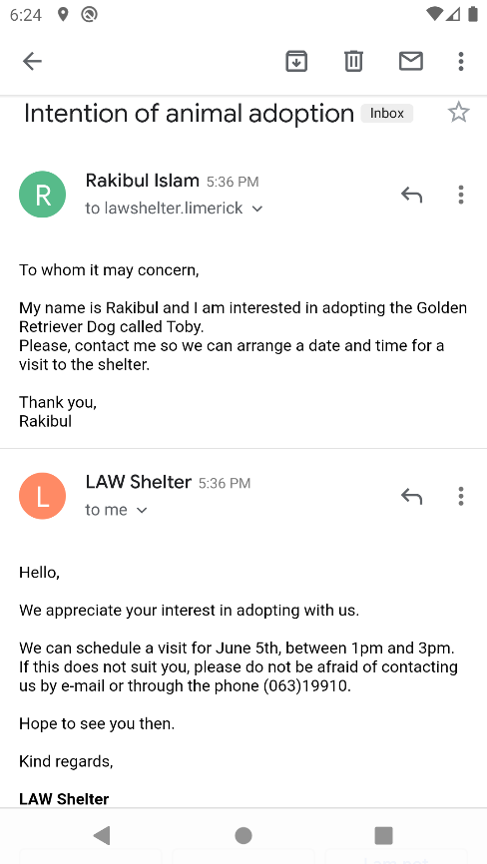

Figure 4.6e: Sample of pre-written email on the left. Email sent and response from the shelter on the right

**4.7 Screen 7: *Shelter Information* Screen**

The *Shelter Information* screen, as the name says, provides with the information stored in the database about the specific shelter. It contains information such as name, phone number, address and email. There also a button to allow the user to go back to the previous screen which is the *Chosen Pet Visualization* Screen, in which the user can visualize the pet once again.

Figure 4.7a illustrates the wireframe for the *Update User Profile* Screen, Figure 4.7b shows snippets of code (Java code to the left, XML code to the right of the figure) for the screen, while Figure 4.7c displays snapshot of the actual application *Update User Profile* Screen.

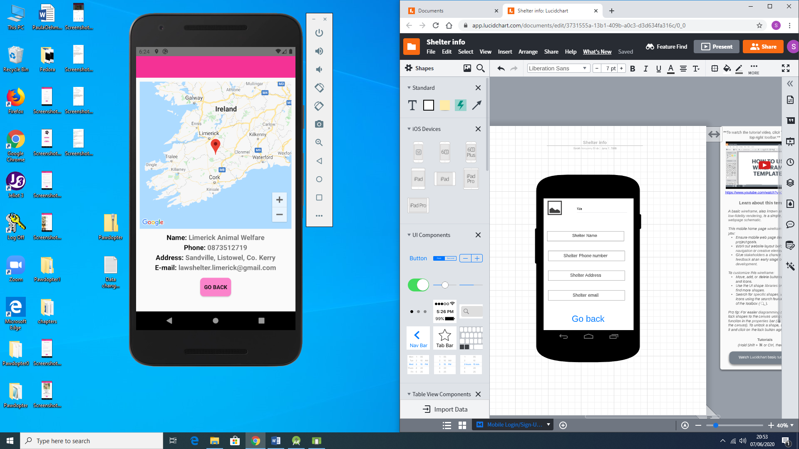

Figure 4.7a: Wireframe of Screen 7: Shelter Information Screen

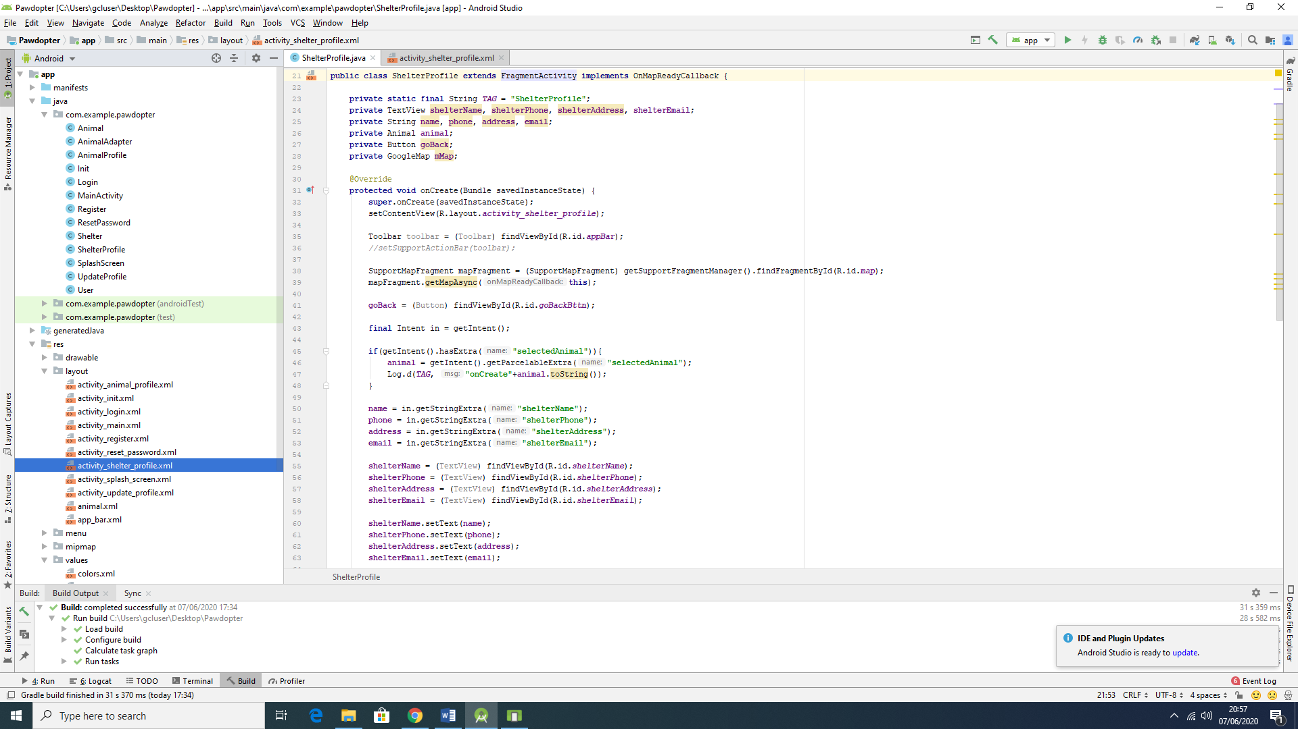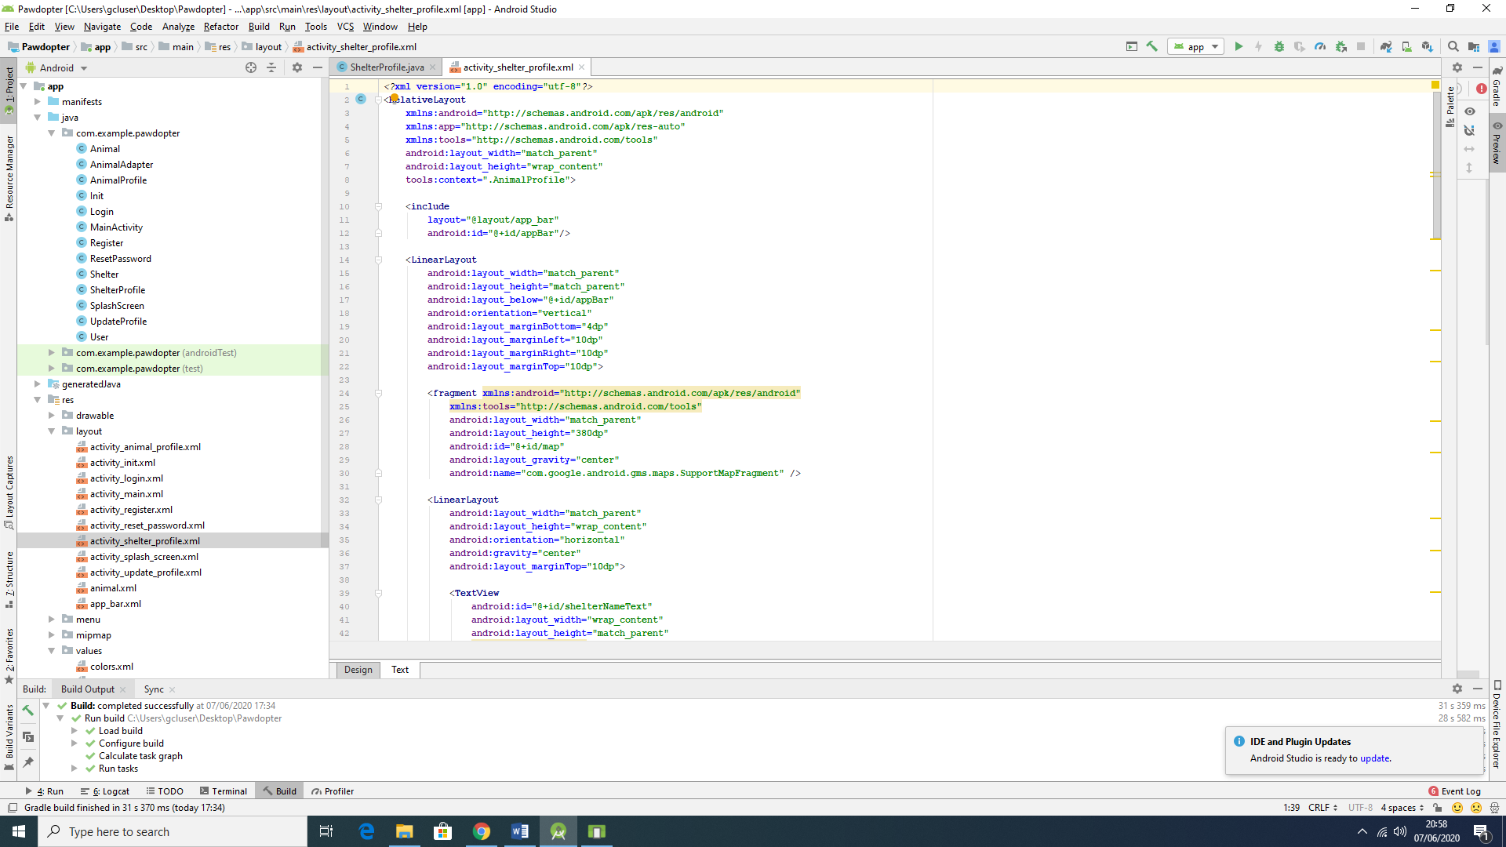

Figure 4.7b: Snippets of code for Screen 7: Shelter Information Screen

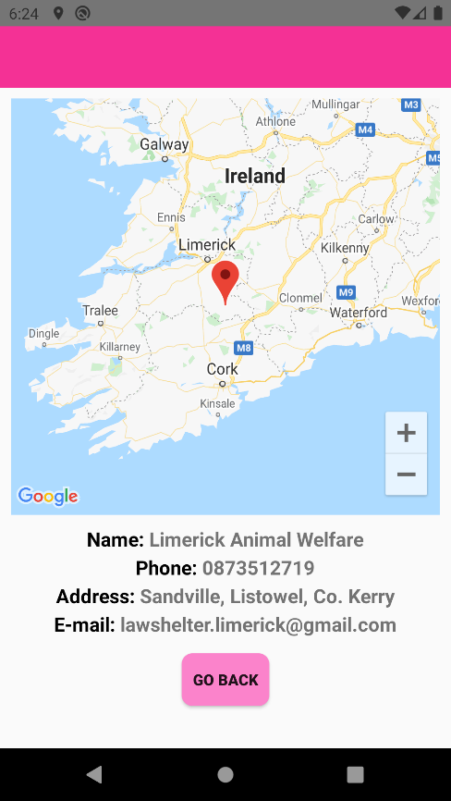

Figure 4.7c: Snapshot of the actual Screen 7: Shelter Information Screen

The wireframe and the actual screen differ in a way that we were able to provide a google maps image of the location of the shelter. Which means that the user can not only see readable information but it can actually see on the map and calculate the advantages and disadvantages of adopting such animal. This image is placed above all the written information on the shelter.

**4.8 Screen 8: *Reset Password* Screen**

The *Reset Password* Screen is as simple as it can be. It provides a field to be field by the user with the email once given during the registration process and a button to activate the resetting password. Once the user clicks on the button an automatic email is sent to the user. This email is created and sent from the database itself.

Figure 4.8a illustrates the wireframe for the *Reset Password* Screen, Figure 4.8b shows snippets of code (Java code to the left, XML code to the right of the figure) for the screen, while Figure 4.8c displays snapshot of the actual application *Reset Password* Screen.

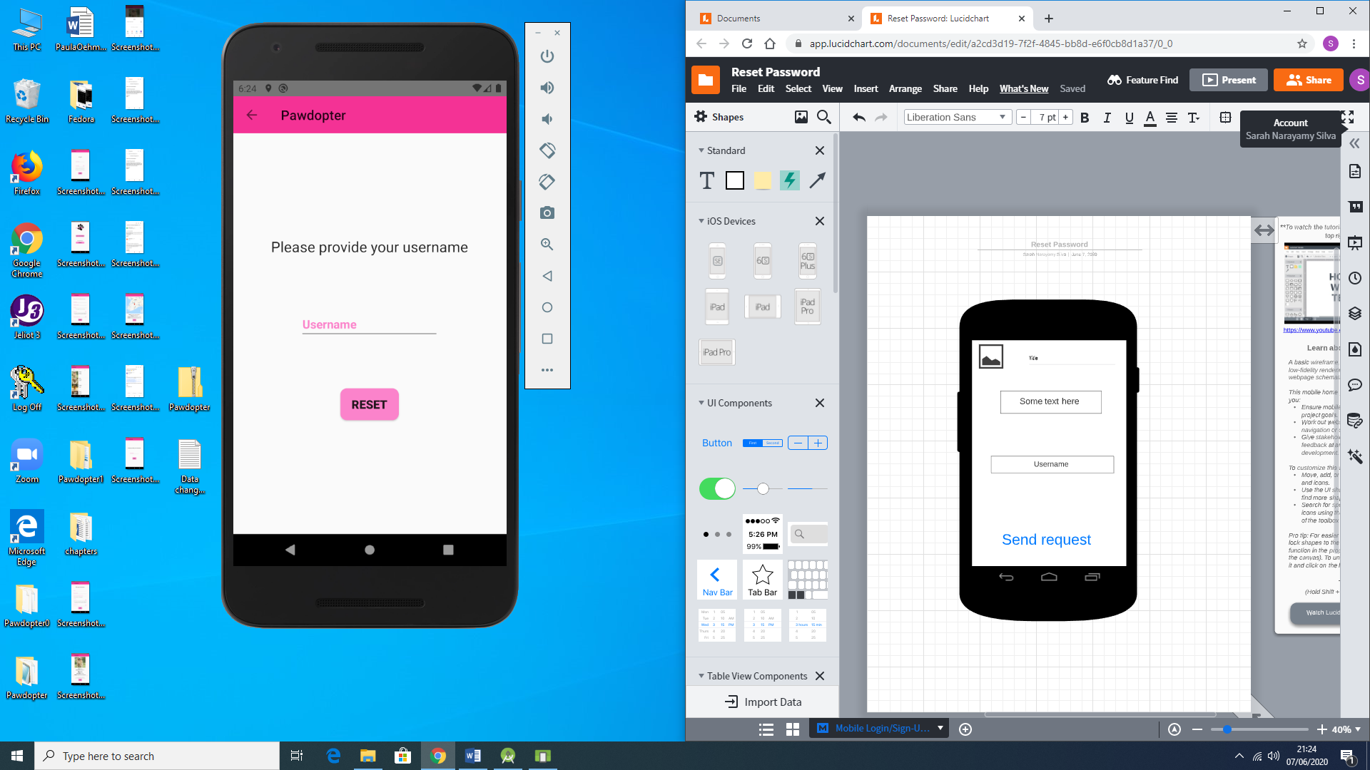

Figure 4.8a: Wireframe of Screen 8: Reset Password Screen

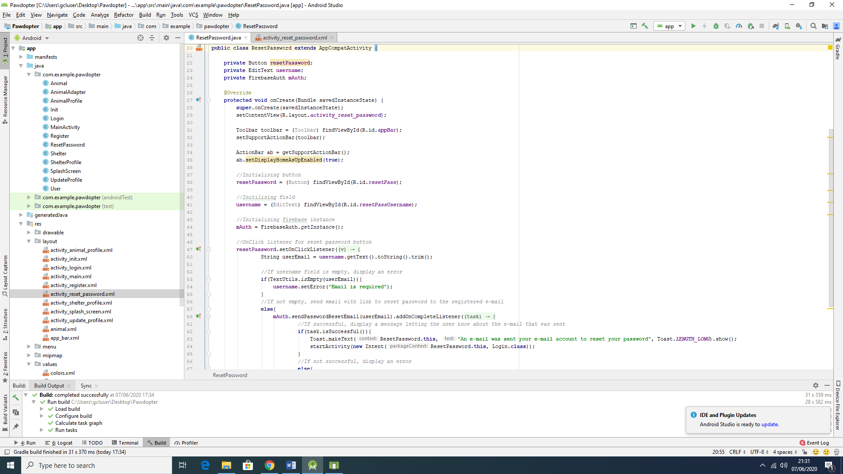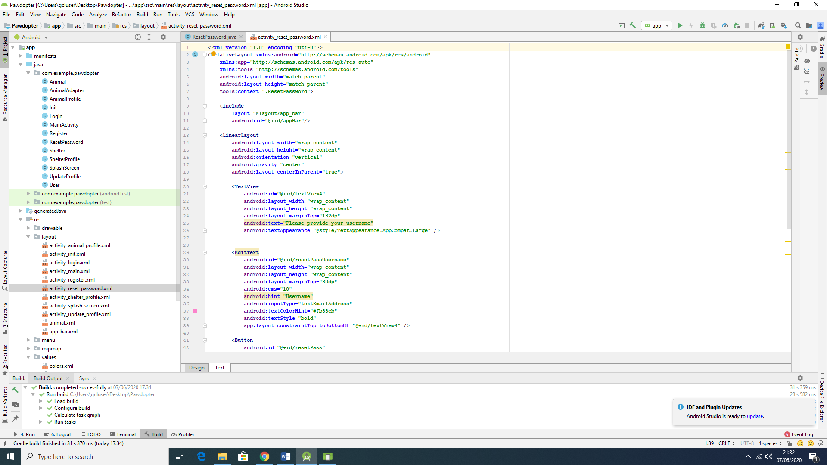

Figure 4.8b: Snippets of code for Screen 8: Reset Password Screen

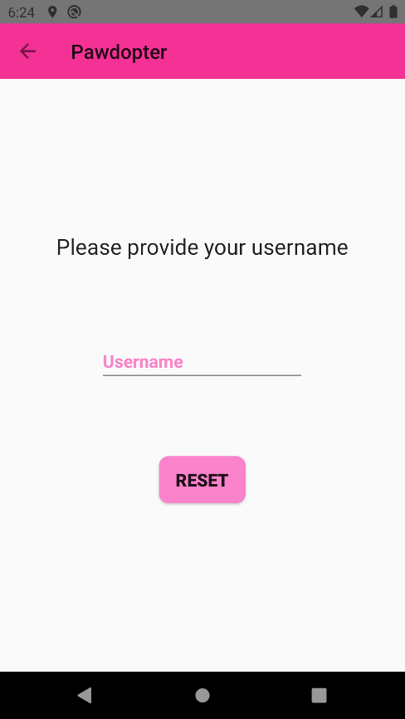

Figure 4.8c: Snapshot of the actual screen 8: Reset Password Screen

The wireframe and the actual screen differ on aspects mentioned before such as logo and name of the application which are replaced by a left arrow and followed by the name respectively. Also, the name of the button was changed from send request to reset with the purpose of making it more user friendly. As mentioned before, the user will receive an automated email from Firebase with a link to reset the password. Figure 4.8d shows the email sent from the database.

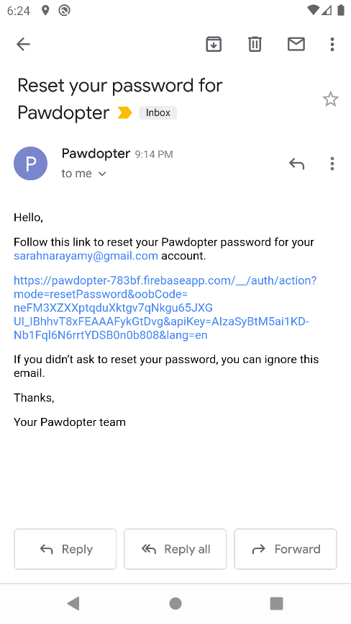

Figure 4.8d: Email sent by Firebase to reset password

It is not possible to show the before and after the password has been reset because this functionality is made by the Firebase Authentication provider.

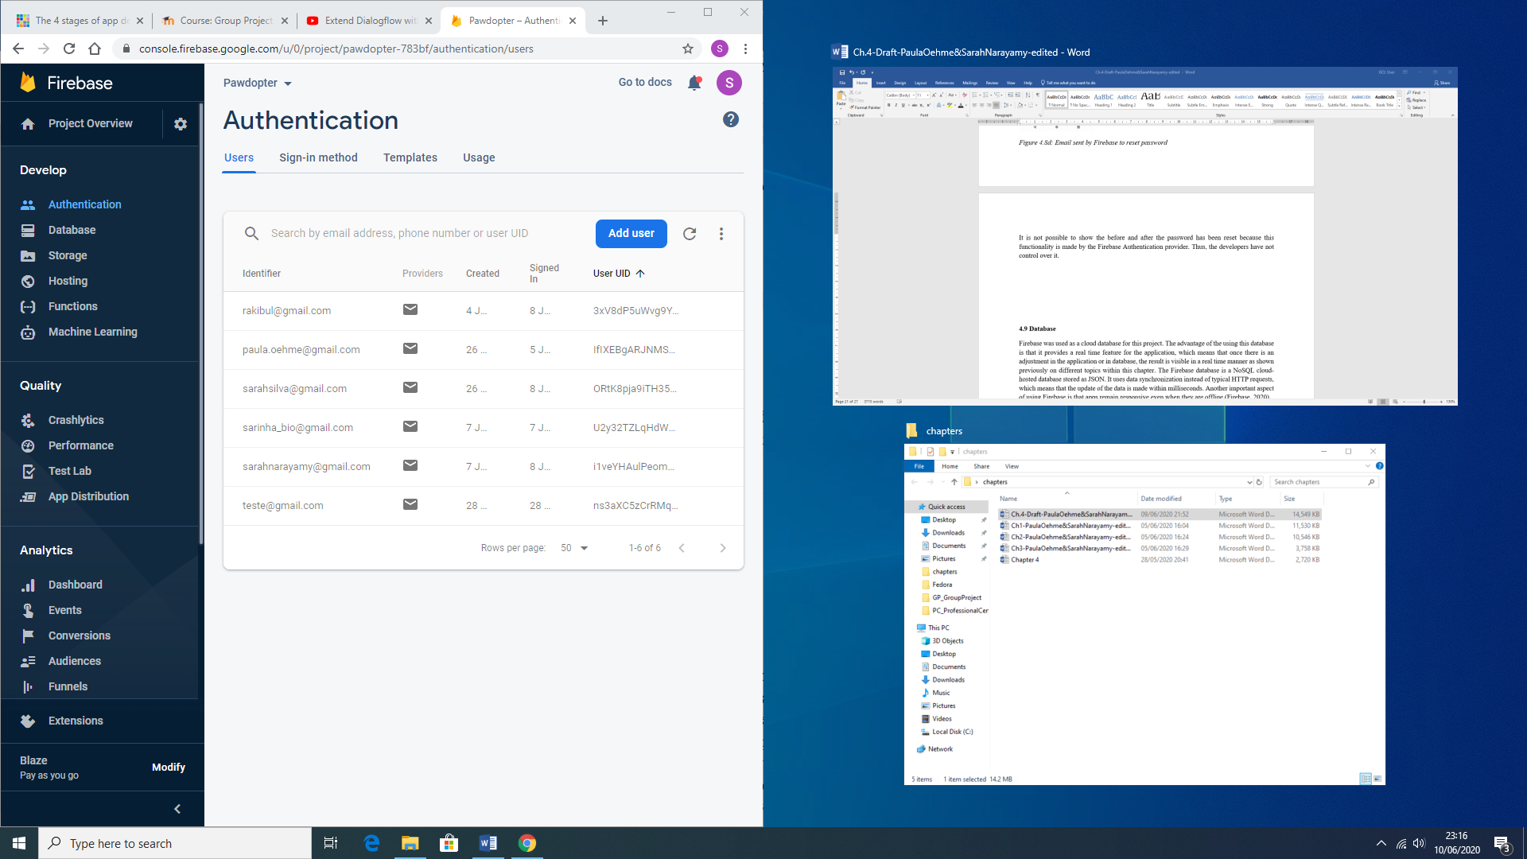

**4.9 Database**

Firebase was used as a cloud database for this project. The advantage of the using this database is that it provides a real time feature for the application, which means that once there is an adjustment in the application or in database, the result is visible in a real time manner as shown previously on different topics within this chapter. The Firebase database is a NoSQL cloud-hosted database stored as JSON. It uses data synchronization instead of typical HTTP requests, which means that the update of the data is made within milliseconds. Another important aspect of using Firebase is that apps remain responsive even when they are offline (Firebase, 2020).

Figure 4.9a shows the general representation of the database with each collection, as an entity like mentioned in chapter 3. It is important to mention that since we have decided not to create the shelter’s interface, due to time constraints, each animal and animal related information was hard coded into the database. All this information can be retrieved by the application in the code using Android Studio, but the application does not make changes onto the database, except for the user collection.

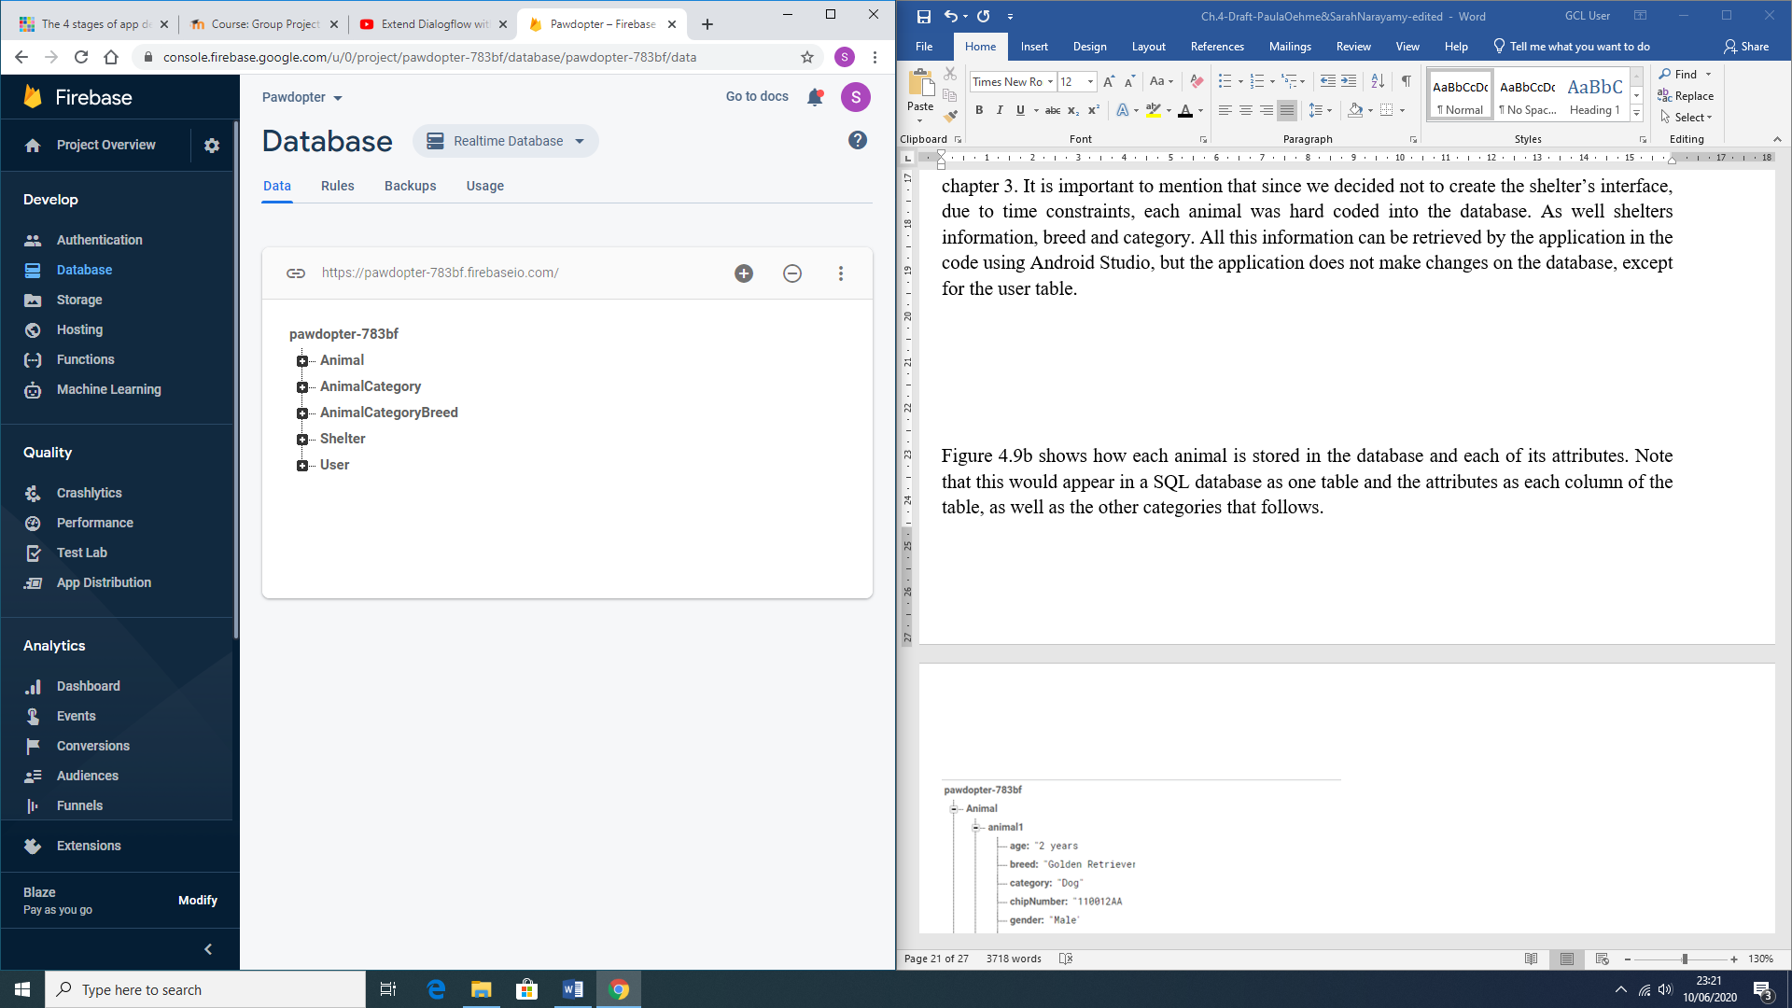

Figure 4.9a: Representation of the database and its collections

Figure 4.9b shows how the animal collection and how each animal is stored in the database and each of its attributes. Note that this would appear in a SQL database as a table and the attributes as each column of the table, as well as the other collections that follows.

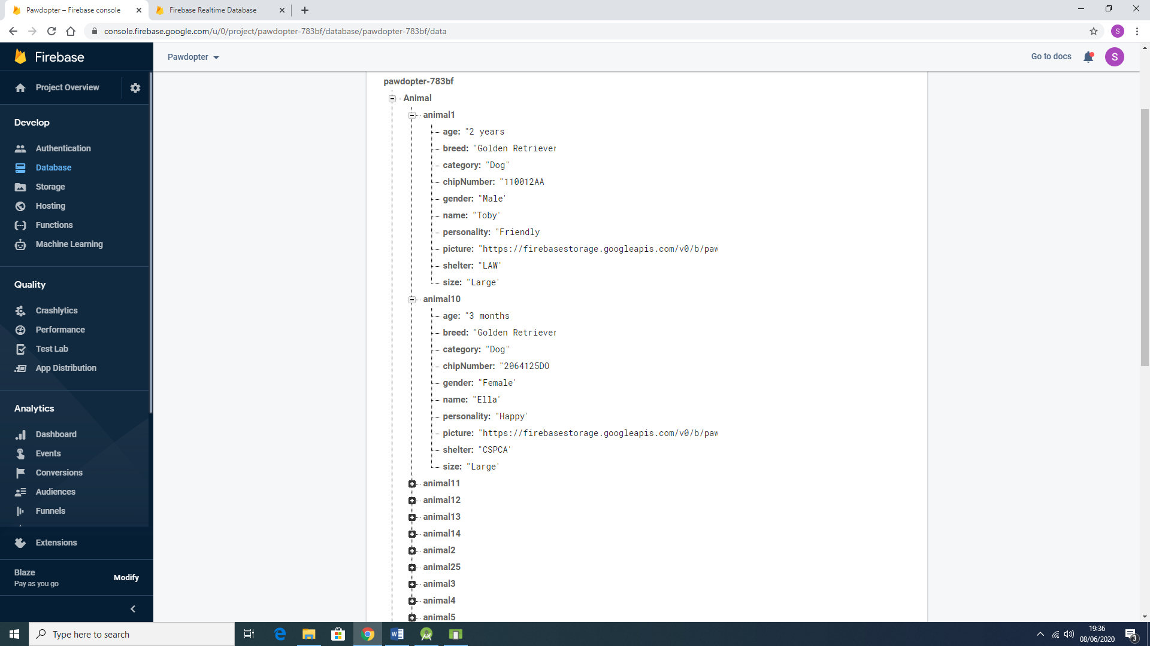

Figure 4.9b: Representation of the Animal collection and its attributes in the database

Figure 4.9c shows how each animal category collection is stored in the database. As mentioned before, this collection would be considered a table and the attribute is applied into the Animal collection as shown above.

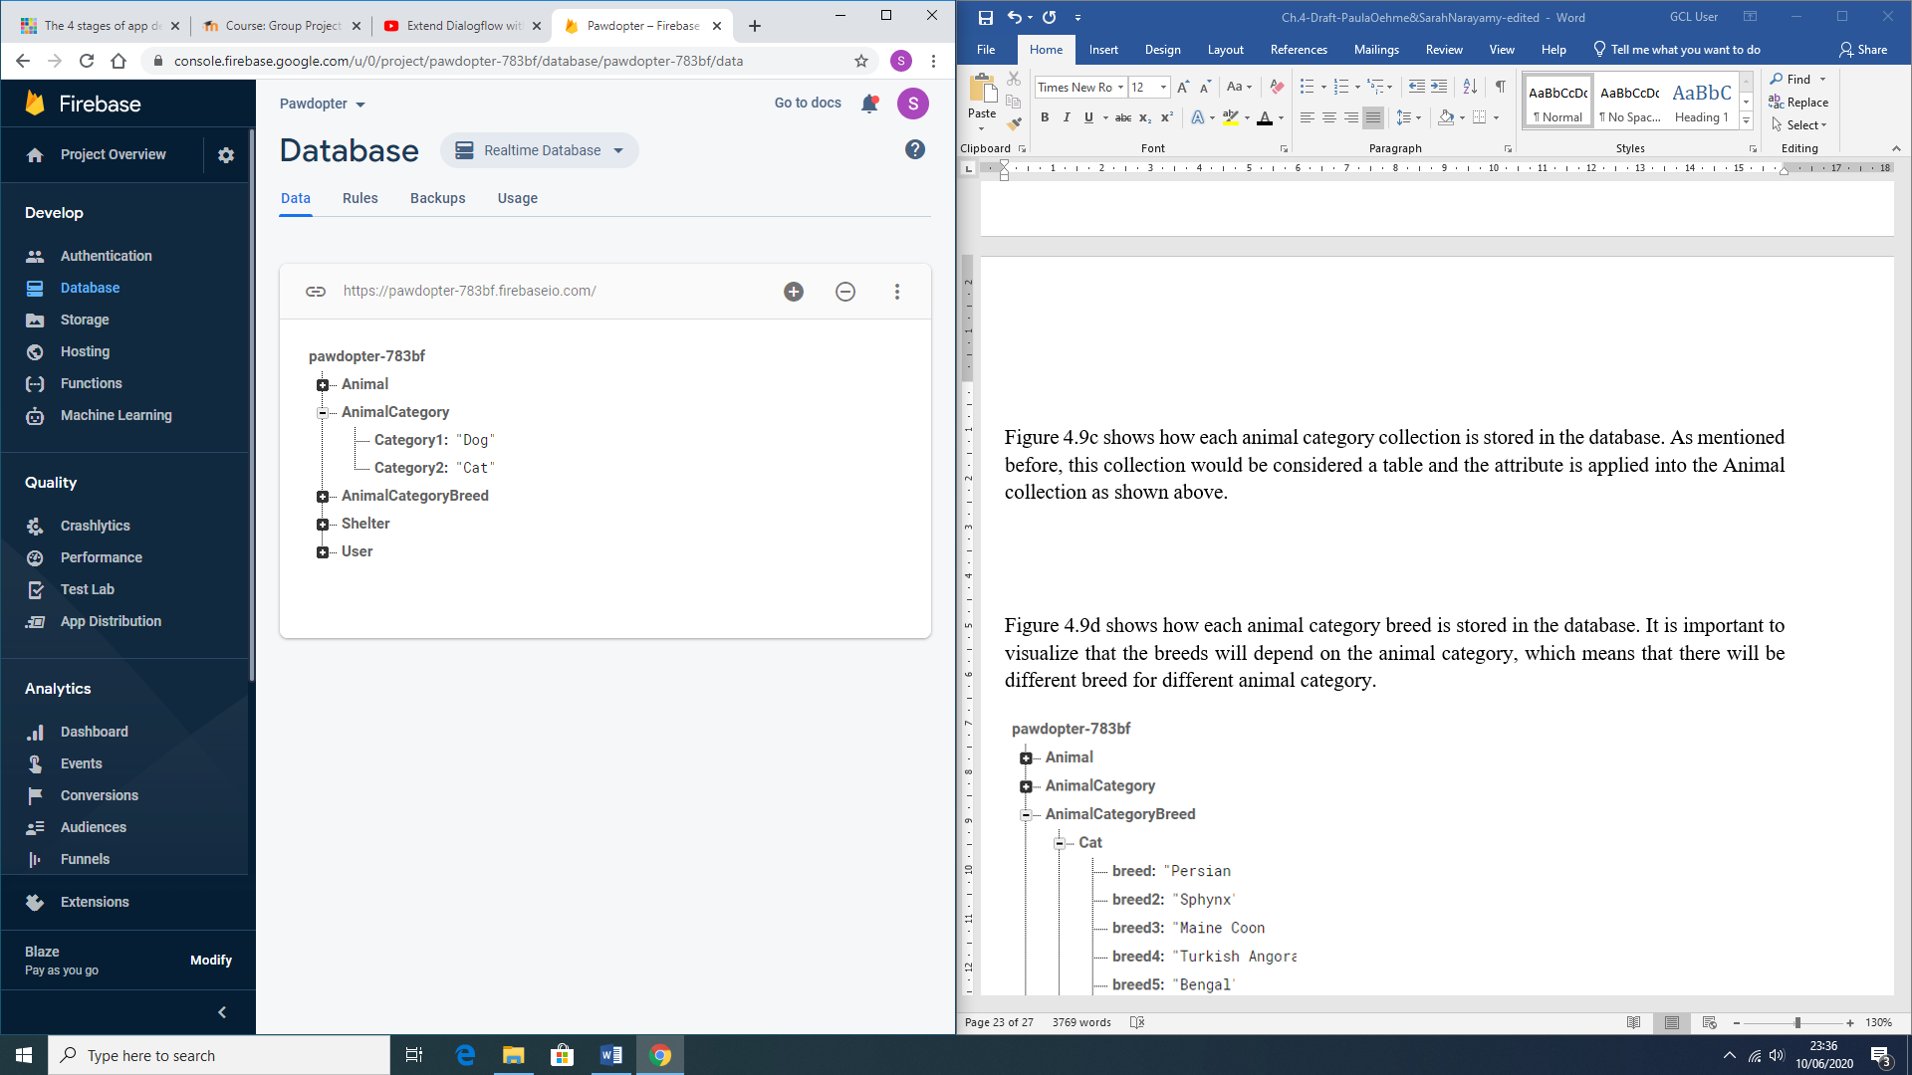

Figure 4.9c: Representation of the Animal Category Collection on the database

Figure 4.9d shows how each animal category breed is stored in the database. It is important to visualize that the breeds will depend on the animal category, which means that there will be different breeds for different animal categories.

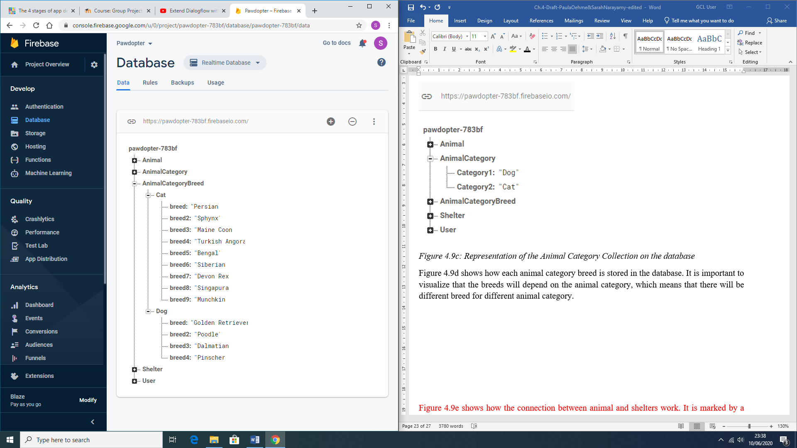

Figure 4.9d: Representation of the Animal Category Breed collection on the database

Figure 4.9f shows how each shelter is saved in the database. The shelter is also connected to the animal as shown on Figure 4.9b.

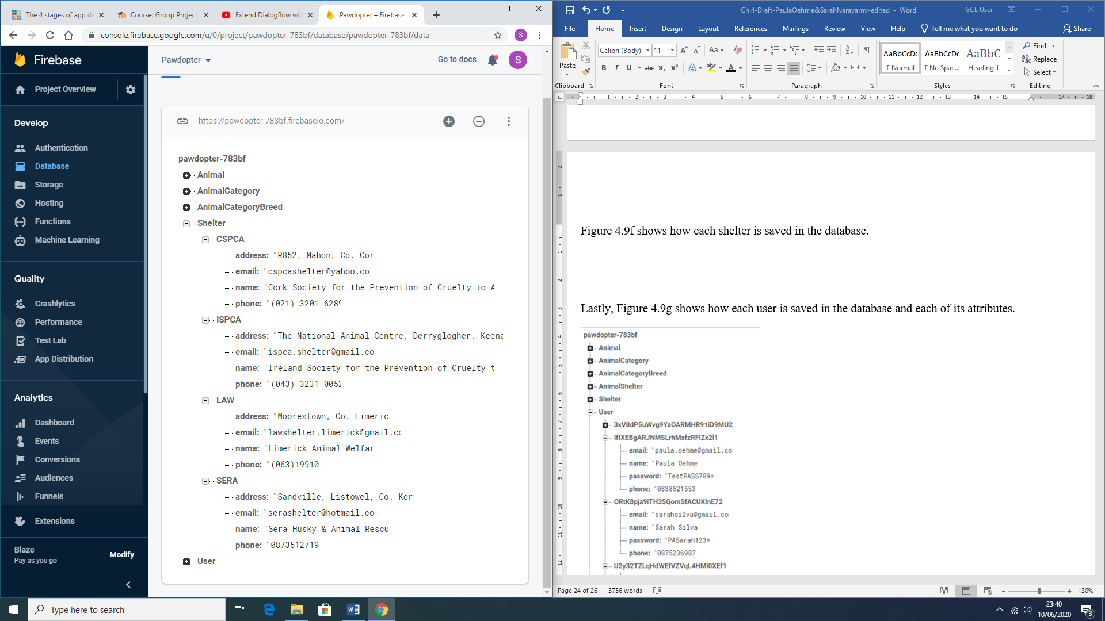

Figure 4.9f: Representation the Shelter collection on the database

Lastly, Figure 4.9g shows how each user is saved in the database and each of its attributes.

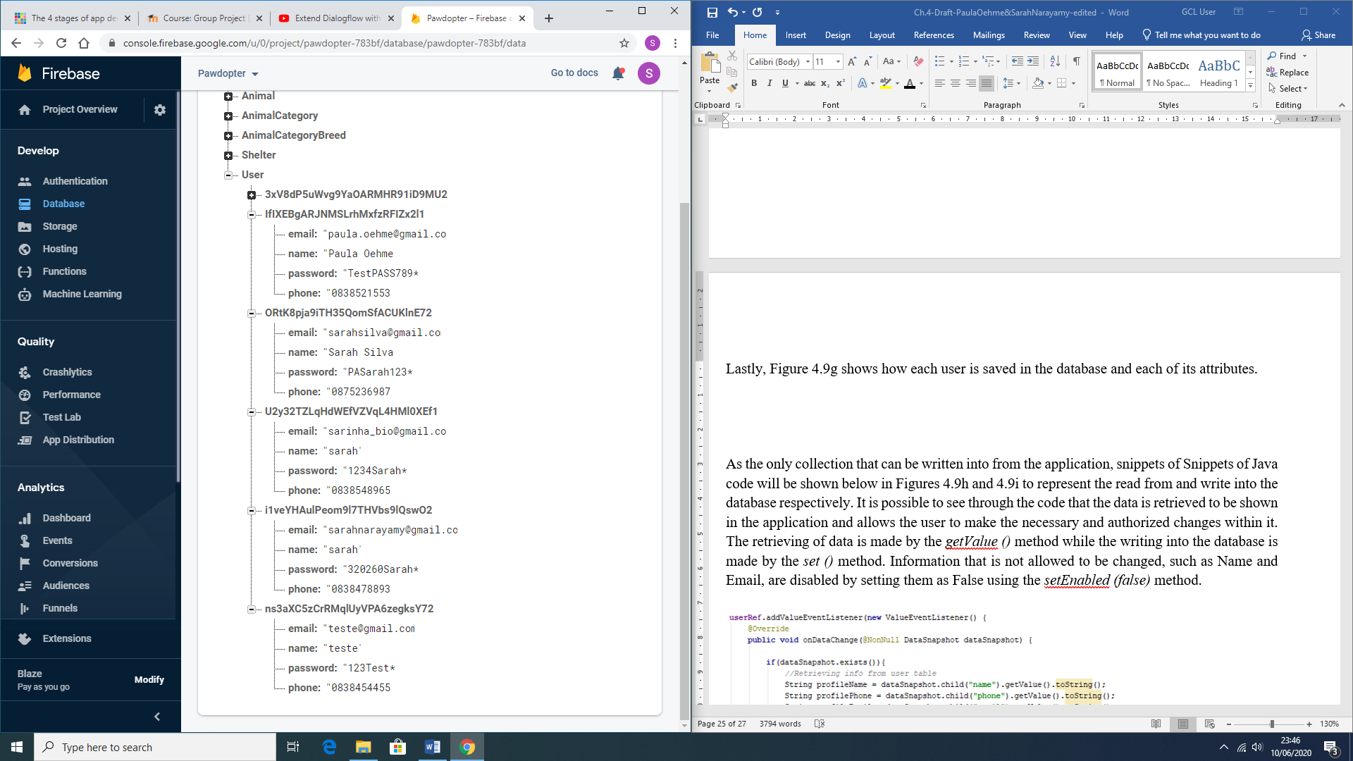

Figure 4.9g: Representation of the User collection in the database

As the only collection that can be written into from the application, snippets of Snippets of Java code will be shown below in Figures 4.9h and 4.9i to represent the read from and write into the database respectively. It is possible to see through the code that the data is retrieved to be shown in the application and allows the user to make the necessary and authorized changes within it. The retrieving of data is made by the *getValue ()* method while the writing into the database is made by the *set ()* method. Information that is not allowed to be changed, such as Name and Email, are disabled by setting them as False using the *setEnabled (false)* method.

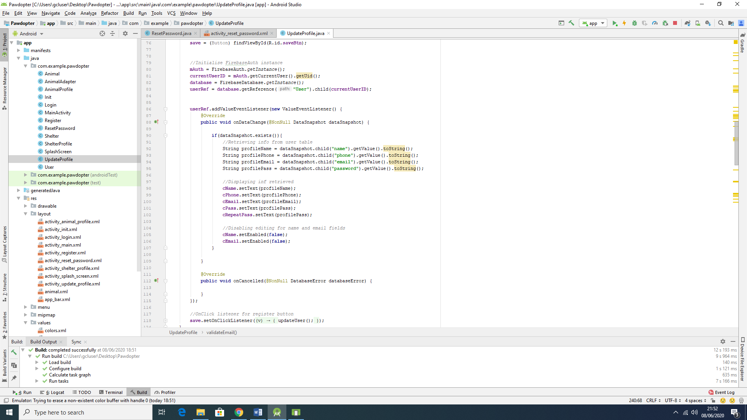

Figure 4.9h: Snippets of code showing read from and write into the database

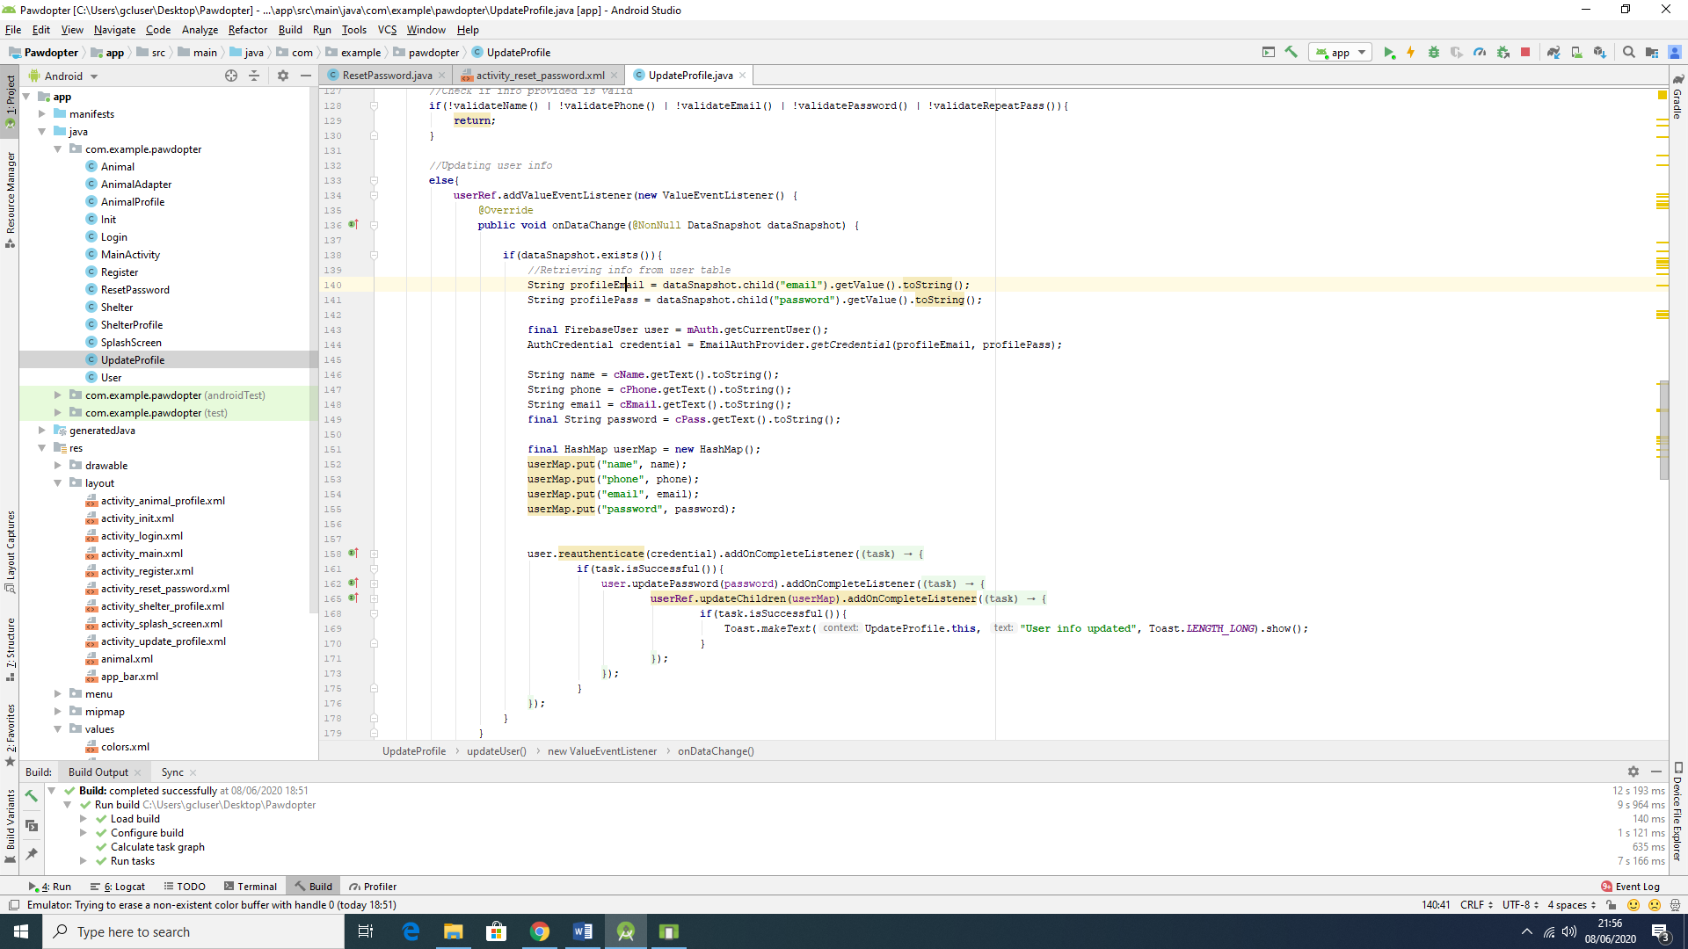

Figure 4.9i: Snippets of code showing read from and write into the database

**4.10 Dialogflow**

Dialogflow is a platform that is powered by Google’s machine learning, which means that it incorporates this expertise in order develop products such as Google Cloud Speech-to-text (Dialogflow, 2020). This platform handles the interpreting and processing of natural language so it can provide an end-user experience of high-quality conversation. It uses concepts such as Agents, Intents, Entities, Follow-up intents, Fulfilment for integrations and so on. Agents are responsible for handling conversations with the end-user.By using dialogflow, the end-user text or voice is translated into a structured data that the app and services can understand. An intent categorizes what is the user’s intention with the conversation. Several intents can be defined for one agent. An example of an intent is currency converter as an Agent, if the user asks “How much can I get in Brazilian Real?” and dialogflow would match the expression to the currency converter intent. An agent is composed of training phrases, actions, parameters and responses. Figure 4.10a show the connection between the user-expressions, the agent and the intents (Google Cloud, 2020).

To active the Google Assistant within the Google Home or through your phone, the user has to say an activation phrase, in this case “Hey Google”. The connection with the app is no different than that. In order for Google Assistant to communicate with the app the user must also say an activation phrase, in this case is “Talk to Pet Finder App”. The reason why it uses this phrase instead of “Talk to Pawdopter”, which is the name of the application, is because Google Assistant is not capable of recognize the word Pawdopter also, Google has a rule about this activation phrase which says that it has to have at least two words for Google Assistant to recognize it. Thus, in order to have the connection with the application the activation phrase to be said to Google Assistant is: “Hey Google, Talk to Pet Finder App”.

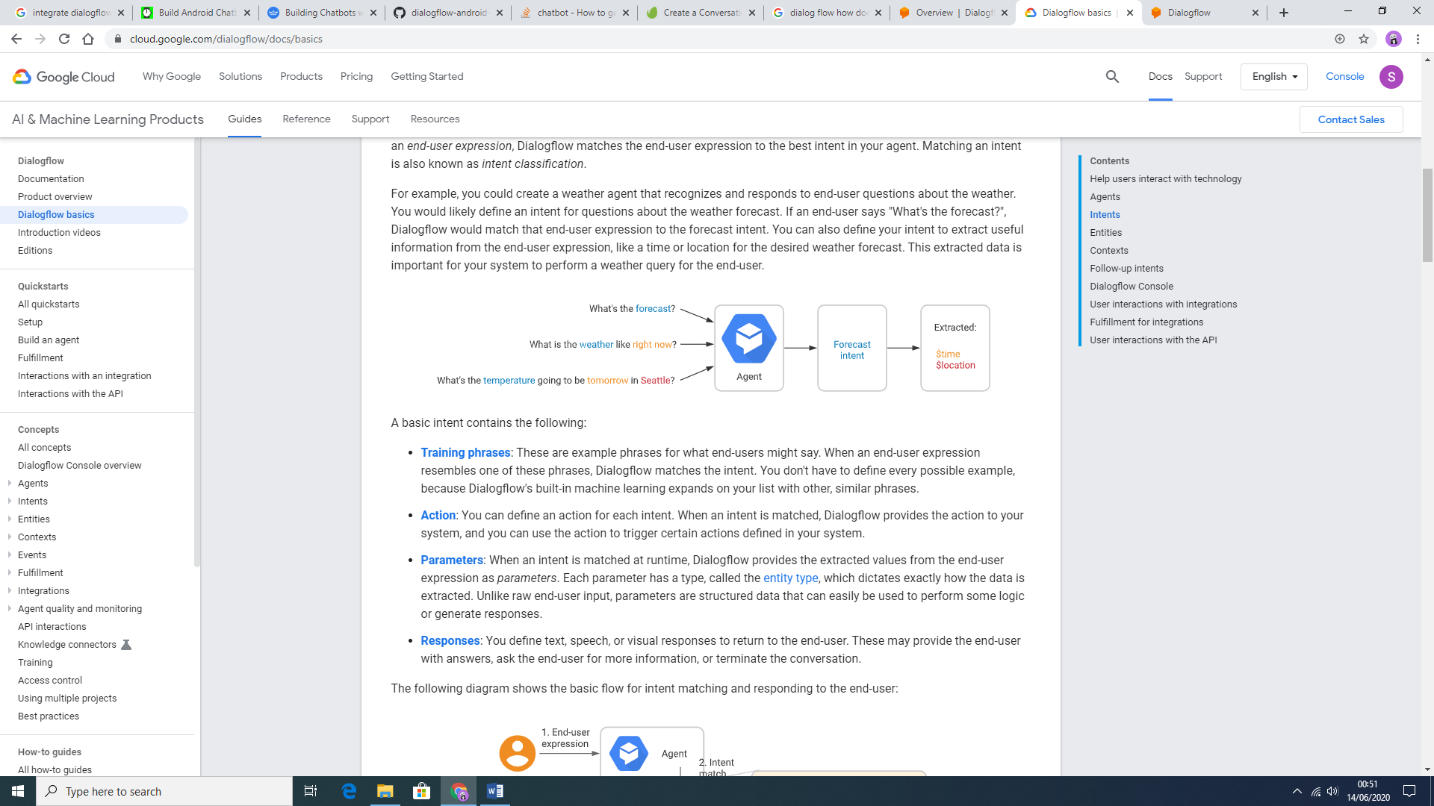

Figure 4.10a: Dialogflow agent and intent demo (Google Cloud, 2020)

Still according to Google Cloud (2020), “each intent [parameter](https://cloud.google.com/dialogflow/docs/intents-actions-parameters#params) has a type, called the [entity type](https://cloud.google.com/dialogflow/docs/entities-overview), which dictates exactly how data from an end-user expression is extracted”. Follow up intents are used to set the context for pair of intents automatically, usually these follow-up intents are common user’s replies such as “Yes”, “No” or “Cancel” but they can also be created according to the developers needs. Fulfilments are used in dialogflow to provide a more dynamic response to the user. That means that when the fulfilment is enabled for an intent, the response that dialogflow provides is based on calling a service defined by the developer such as a database. Figure 4.10b shows the flow of the fulfilment process.

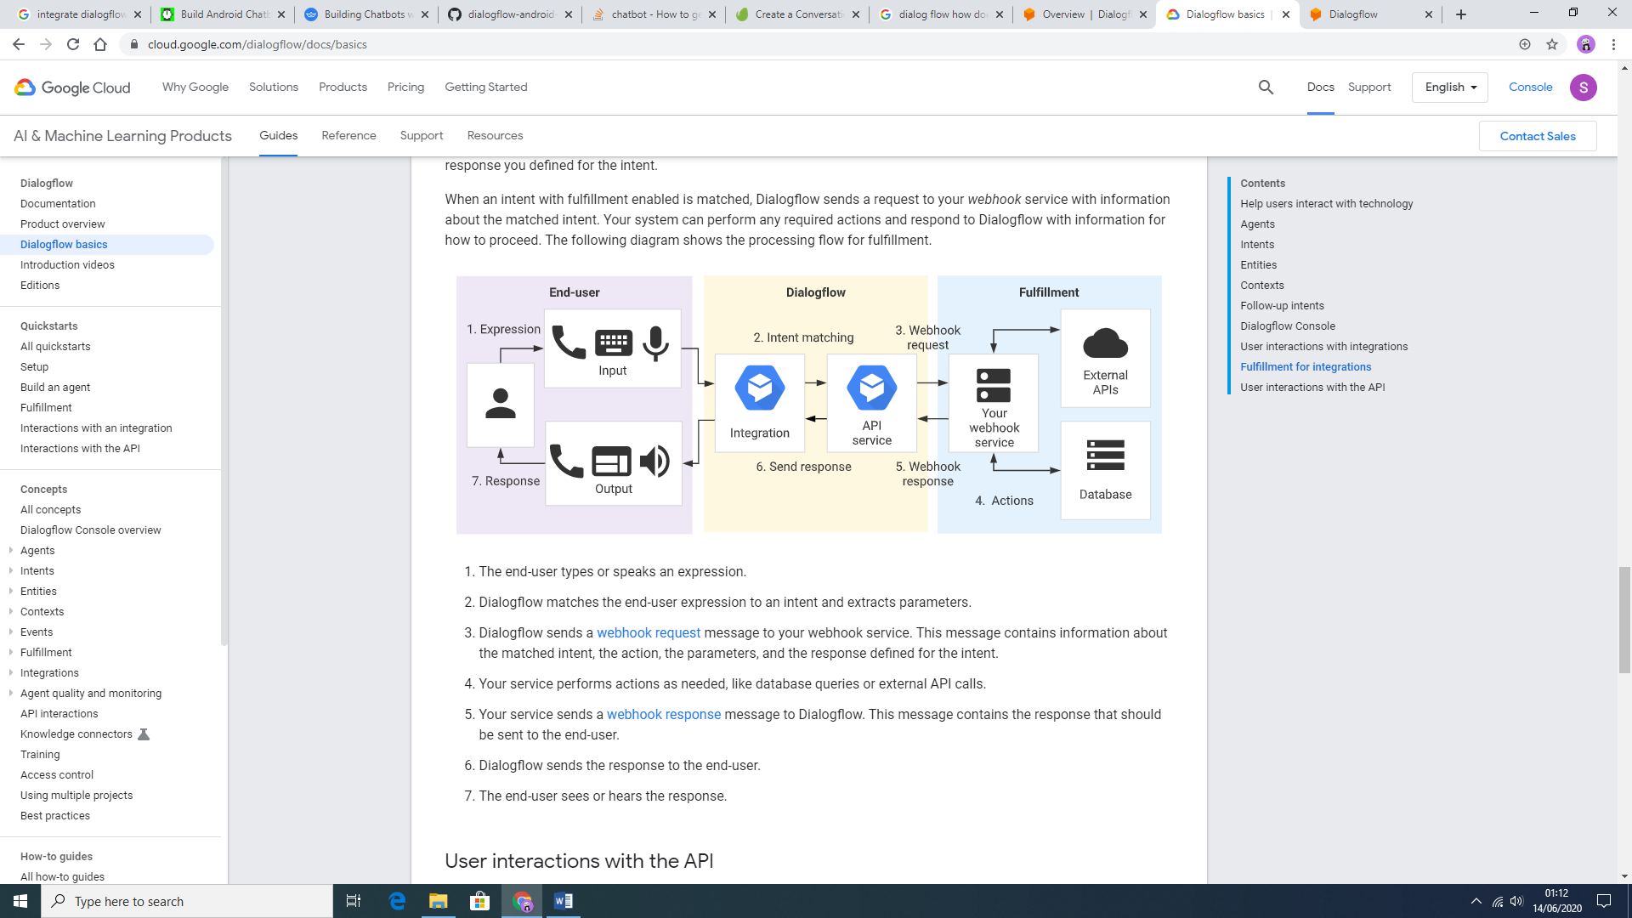

Figure 4.10b: Fulfilment processing flow (Google Cloud, 2020)

This process is developed with JavaScript as a language. Figure 4.10c: represents snippet of code for the fulfilment in this project, showing a function that creates a list of breeds from the database according to what the user has asked for.

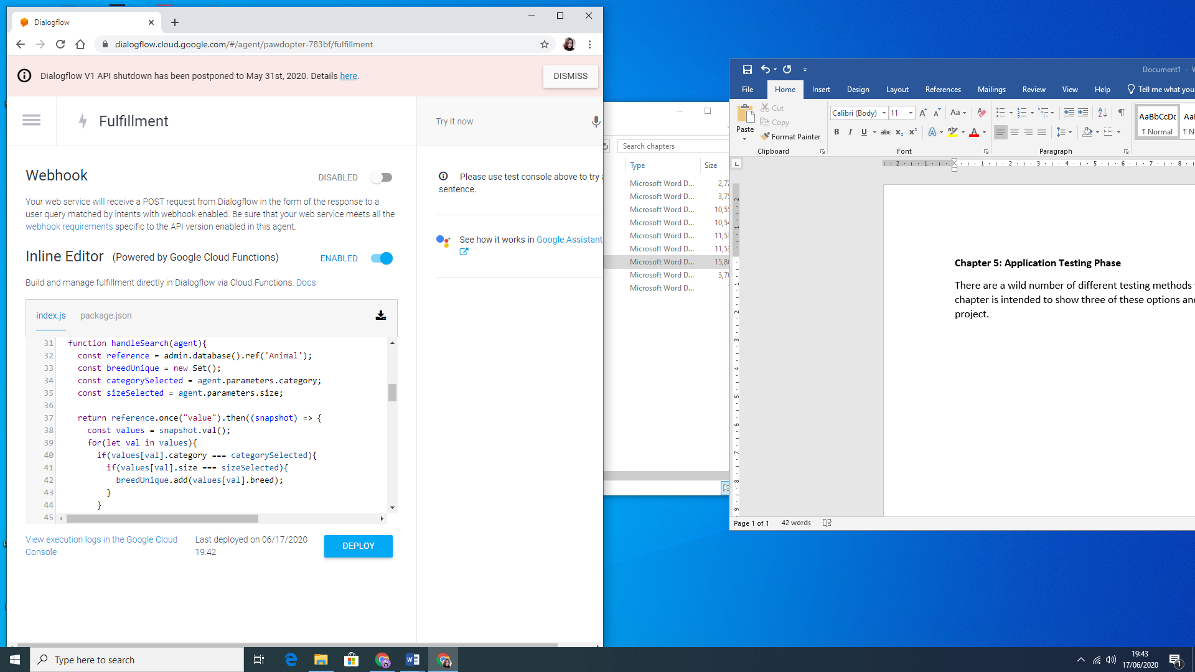

Figure 4.10c: Snippet of code from the Fulfilment in Dialogflow

Figure 4.10d shows the structure of the Intent for this application called LookingForPet.

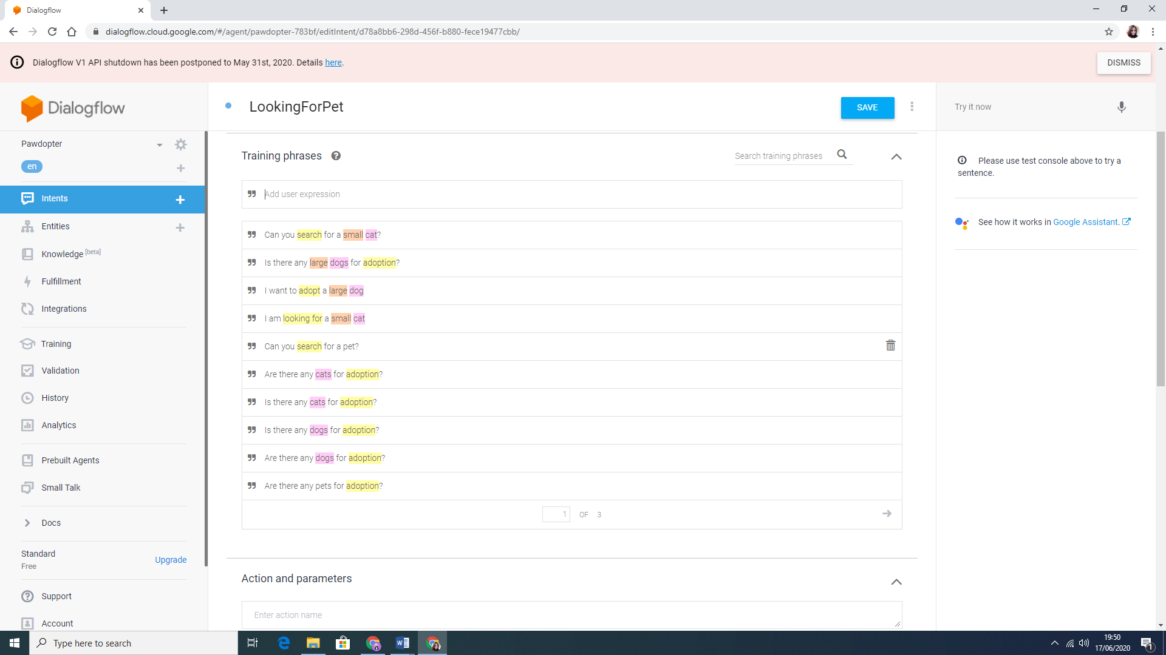 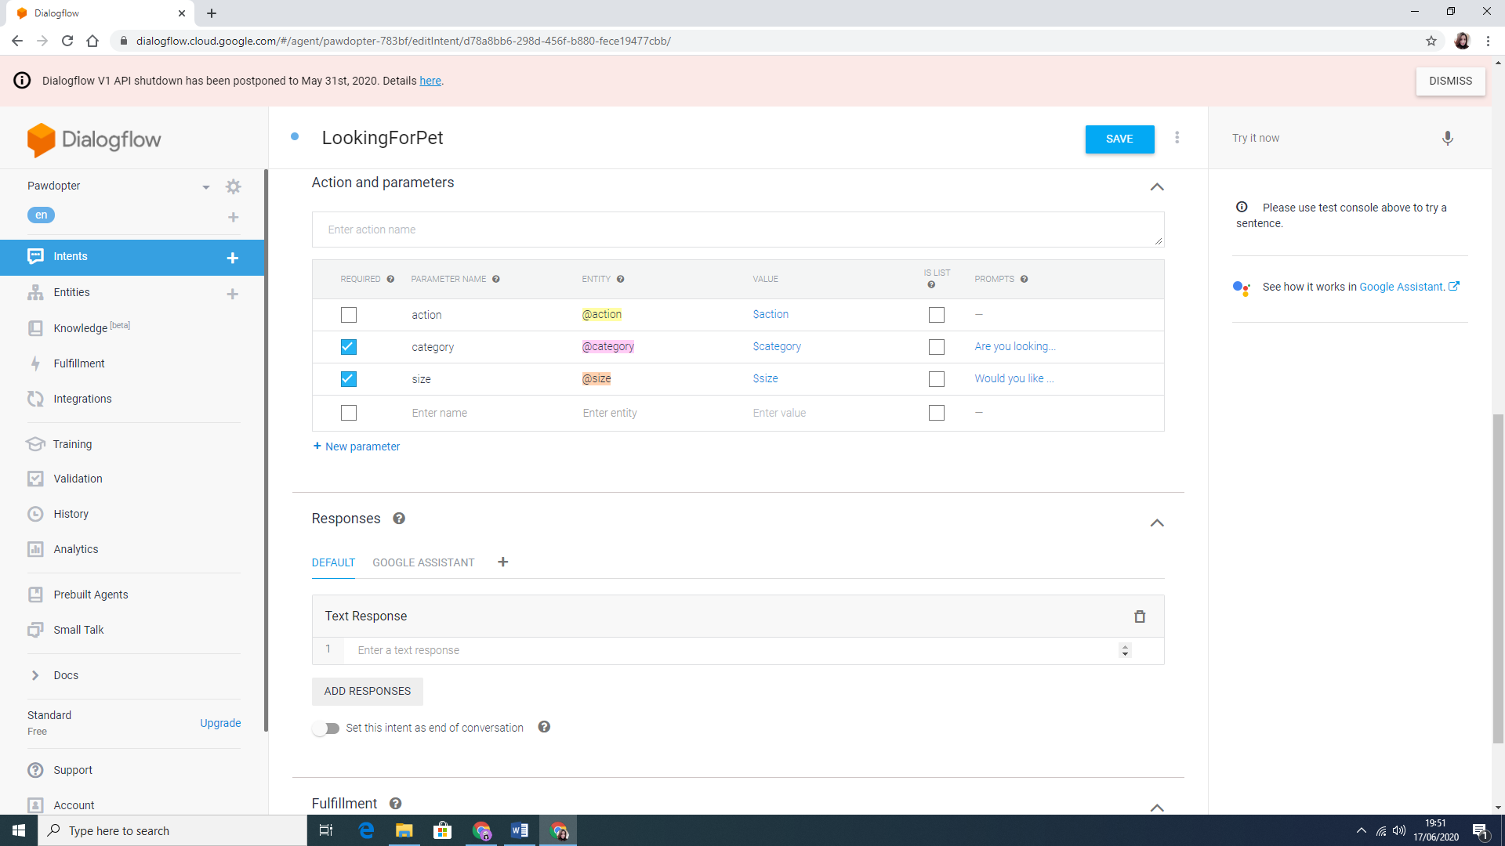

Figure 4.10d: LookingForPet Intent structure

Figure 4.10e show a Follow-up intent structure according to the chosen Breed after selecting the category and size of the desired pet.

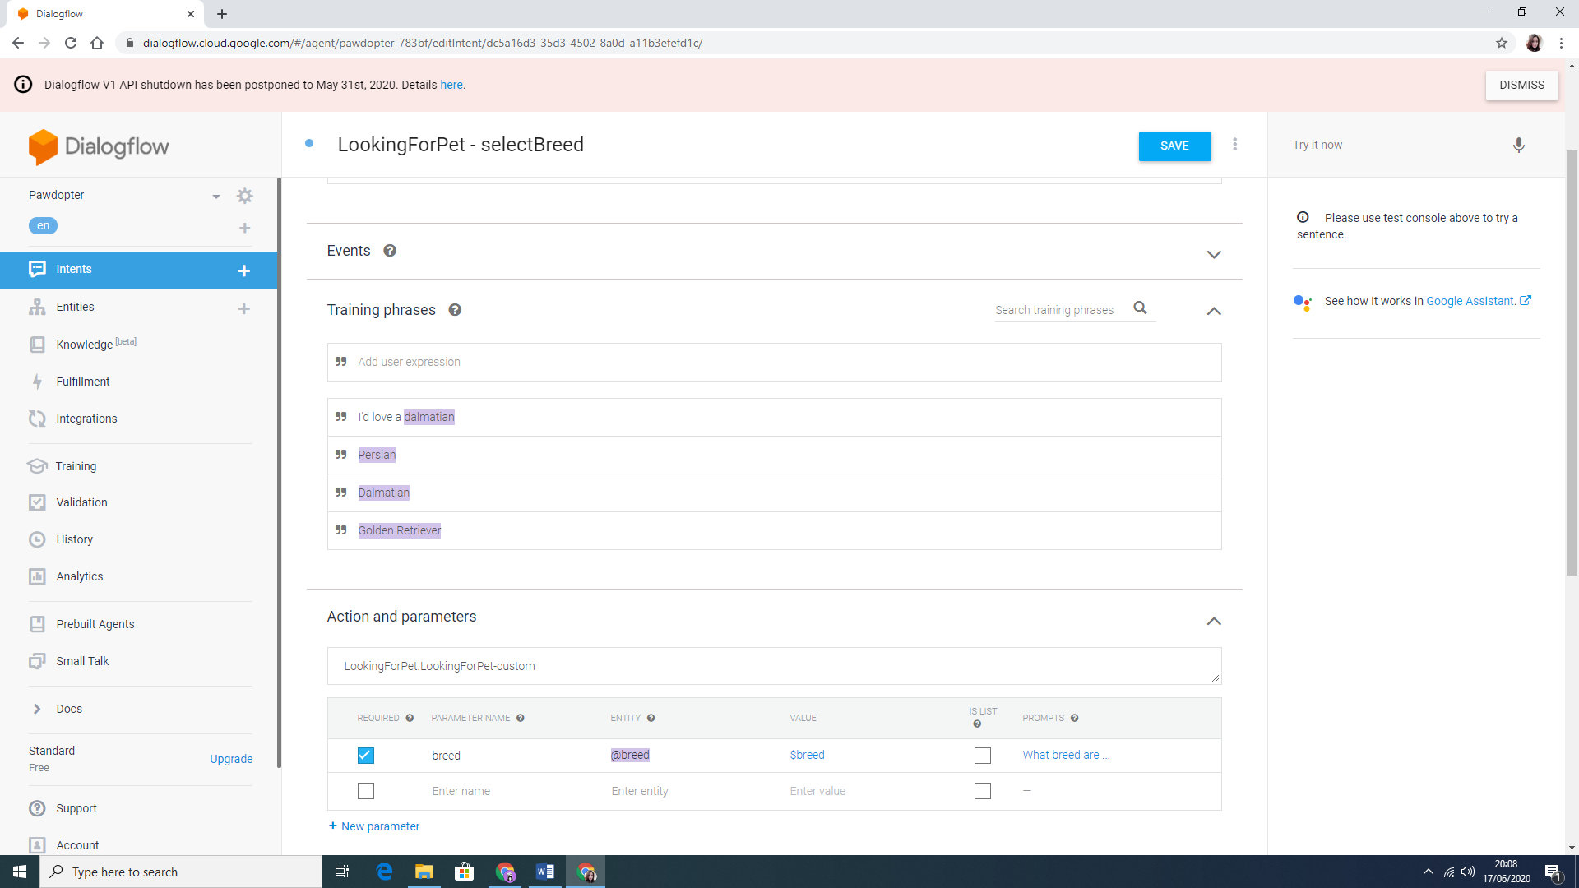

Figure 4.10e: Follow-up intent structure

Figure 4.10f shows the Entities created for this application on the left and the structure of one of these Entities on the right. Each entity, such as cat or dog has its synonyms and the Fuzzy matching selection allows the assistant to match user’s input with the entities even when the spelling or pronunciation are not correct.

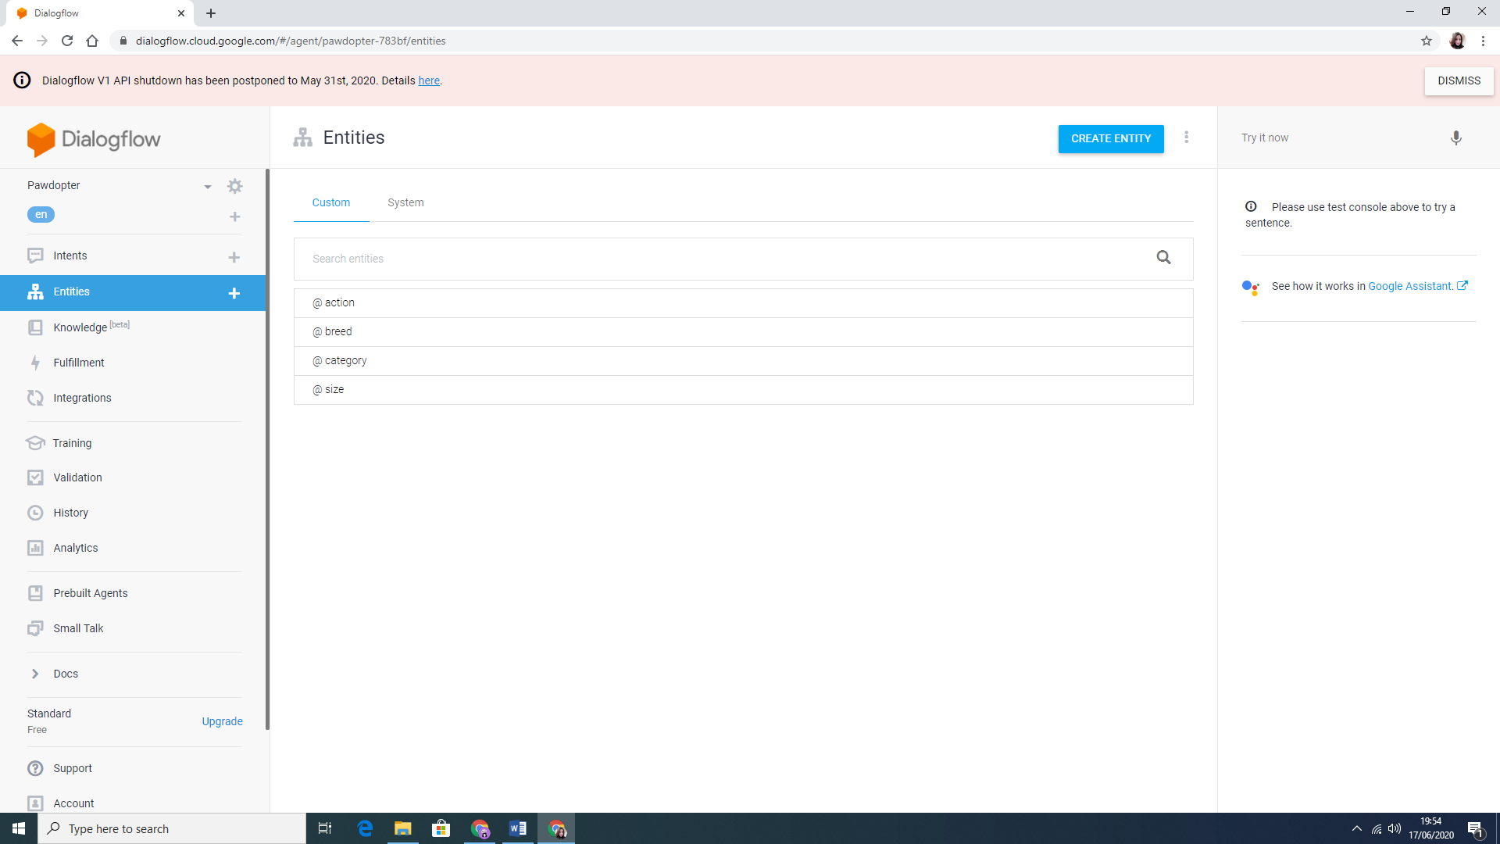 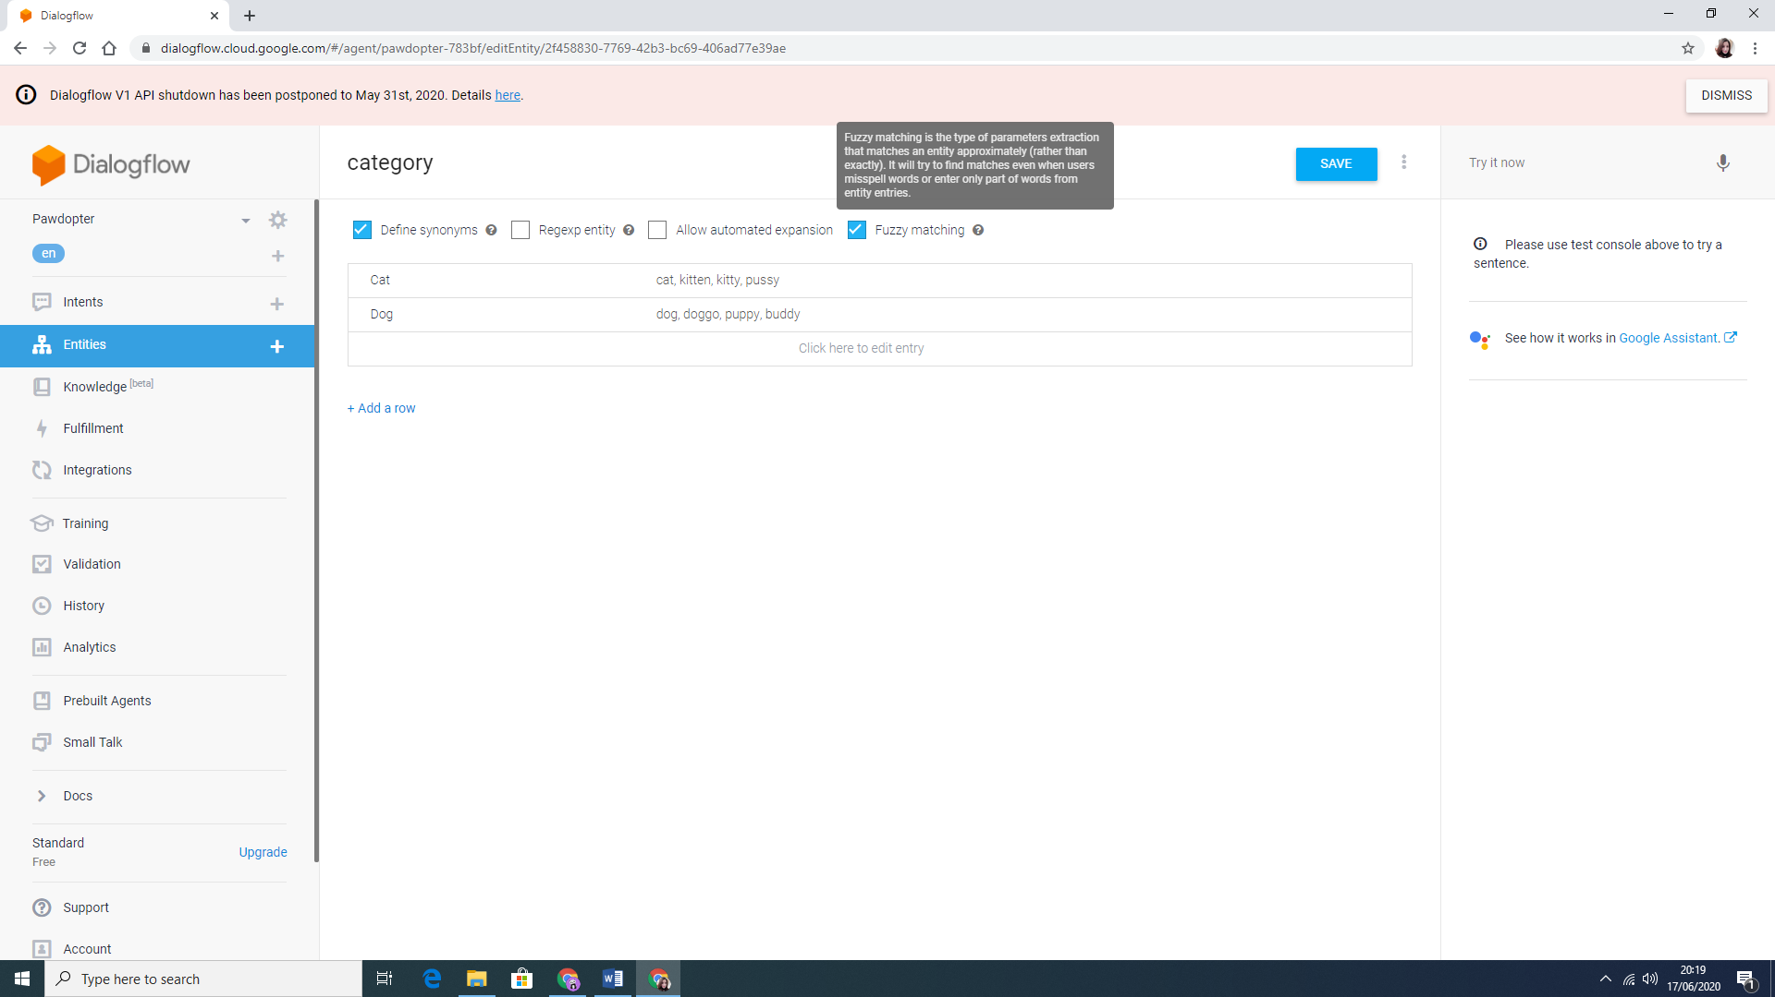

Figure 4.10f: Entities and entity structure

**4.11 Three-Tier Architecture**

This project is based on a Three-Tier Architecture of software development that consists of *User Tier, Application Tier and Database Tier*. *The Presentation Tier or User Tier*, allows the communication with the other two tiers. It represents the Graphical User Interface (GUI) and the communication between the other tiers is made through Application Program Interface (API) calls. In this project *JavaScript* was used to create the Presentation tier. The *Application tier or Logic Tier* uses a programming language (Java) to provide the business logic and the processing of user input for obtaining data and making decision, to support the application’s functions. These functions include network management, security, datastore access, etc. In this project Android Studio was used with Java as a language. The last tier of this architecture is the *Data Tier or Database tier* which is responsible for storing the information. Firebase was used for this project (Rouse, 2020). Figure 4.11a shows the Three-Tier architecture.

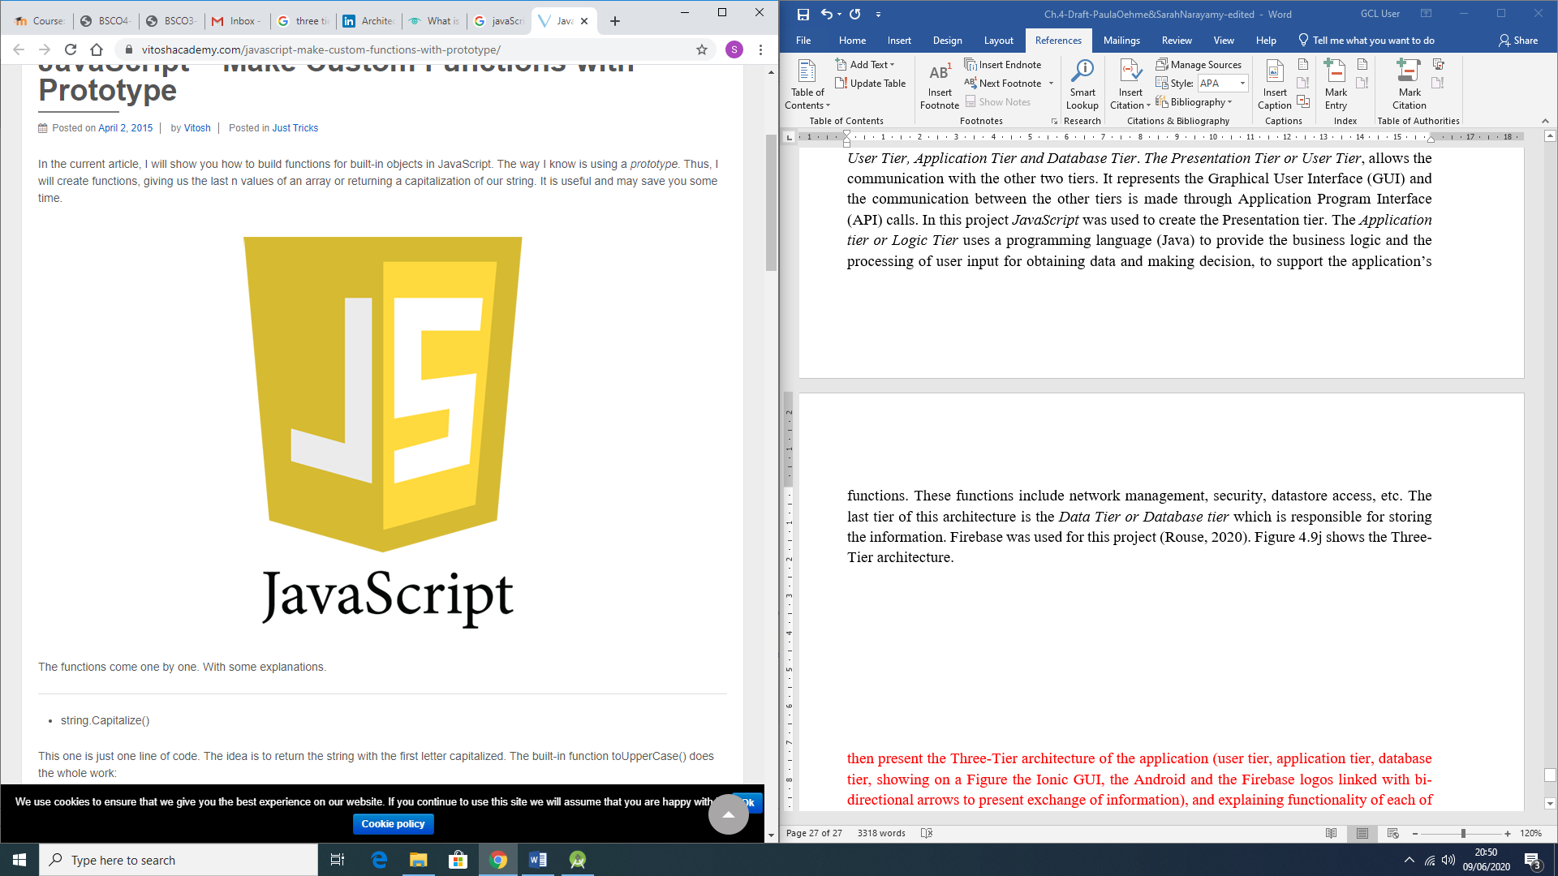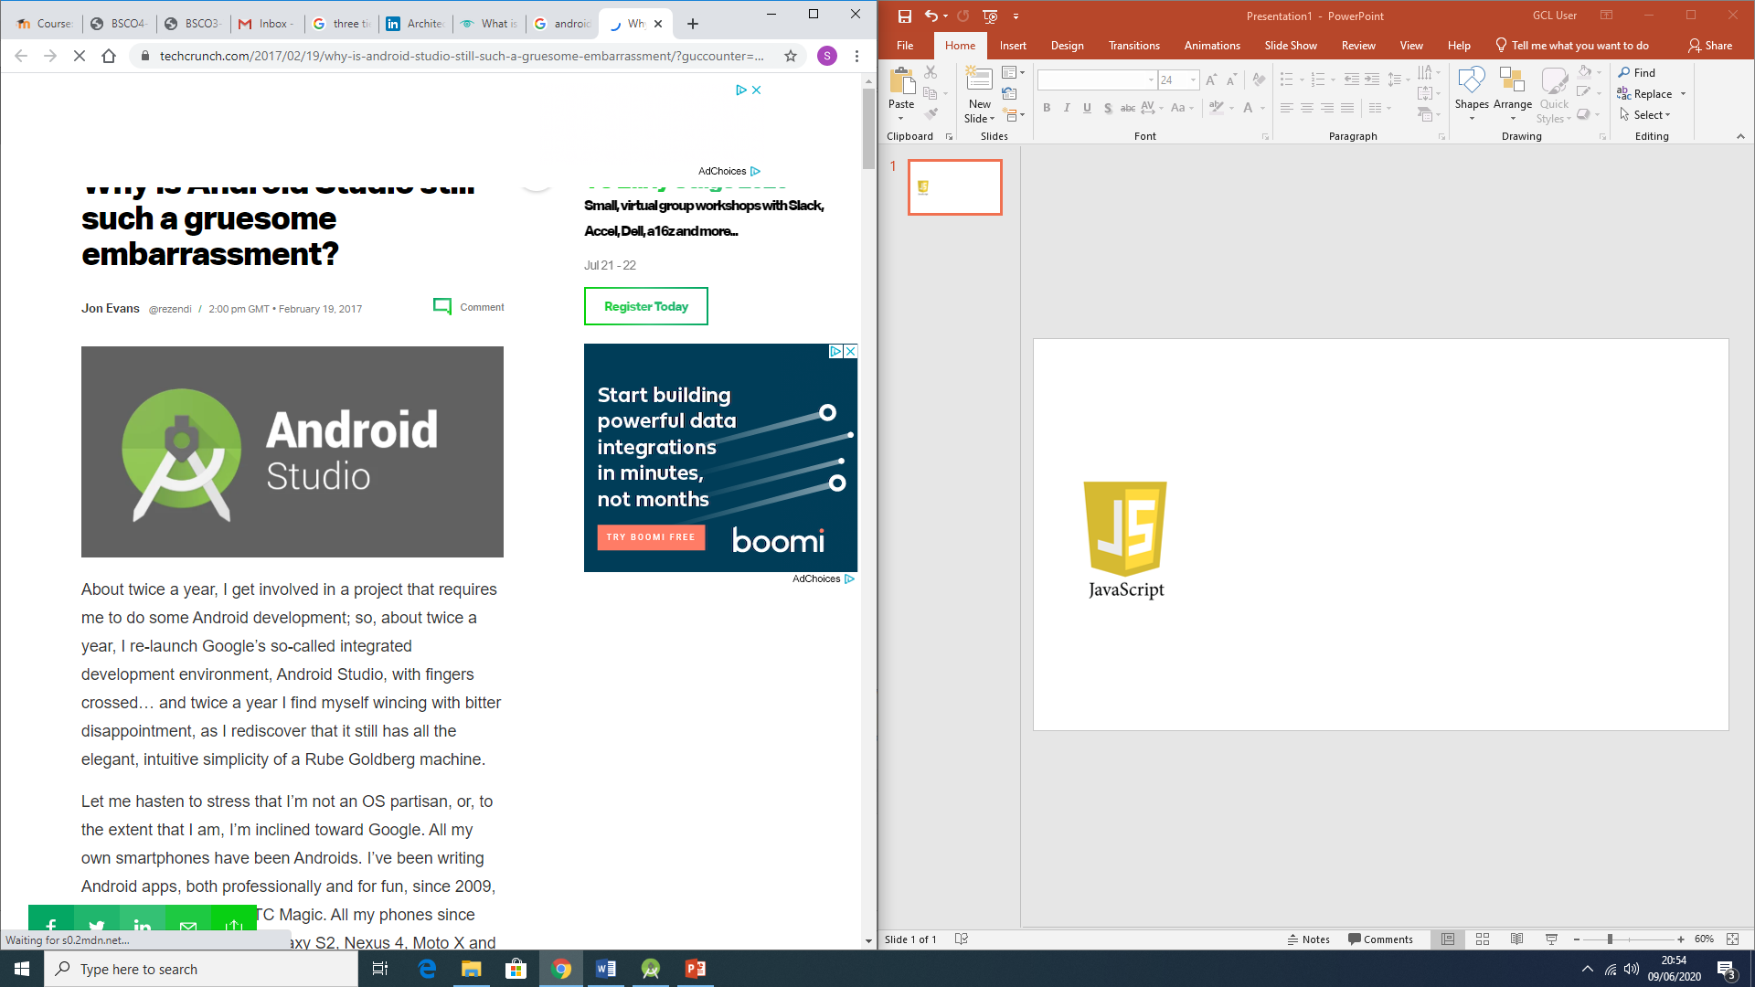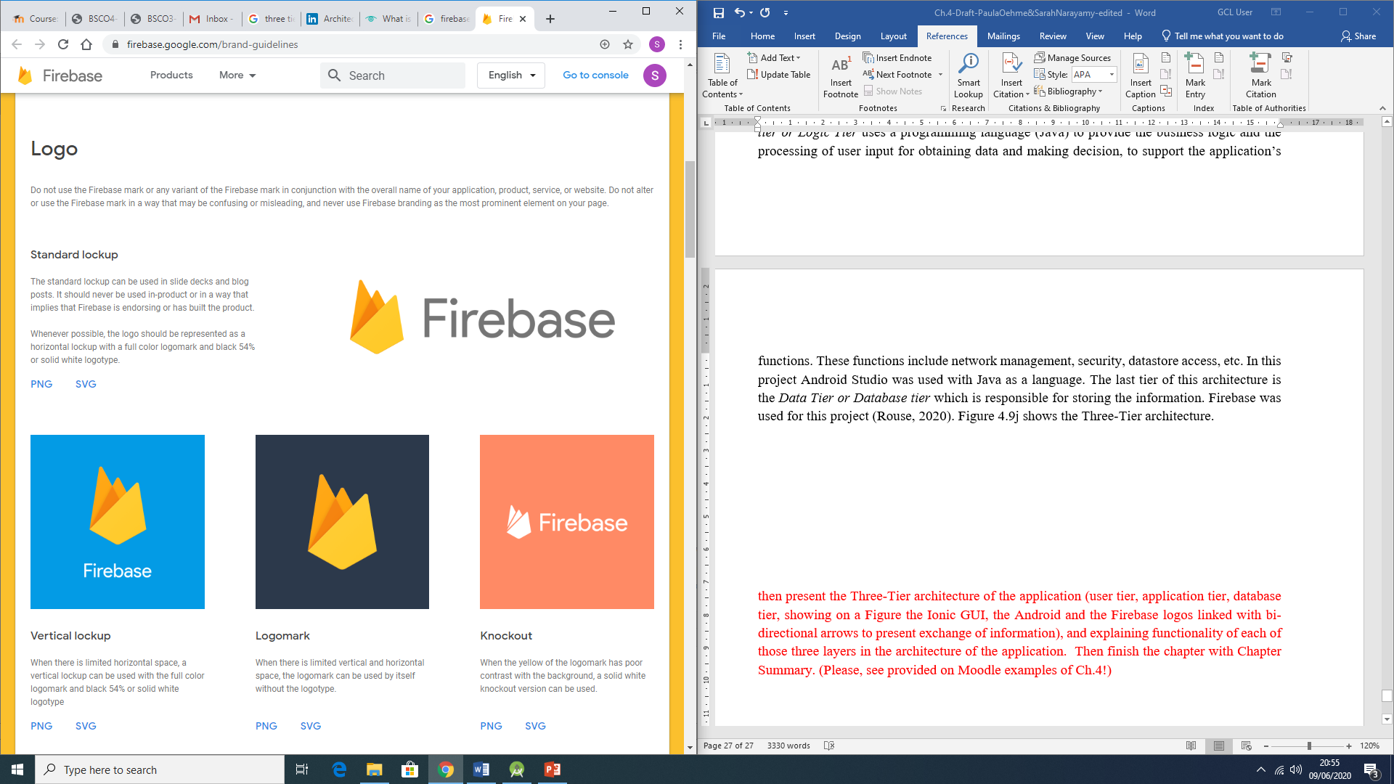

Figure 4.11a: Representation of the Three Tier Architecture

**4.11 Chapter Summary**

This chapter was important to detail the Design and Coding process of the mobile application’s project. Each section illustrates the importance of planning the design and the necessary changes that may be needed to be made within the coding process due to different reasons. These changes were mostly done in order to enhance either the appearance and the functionality of the application.

The next chapter will discuss the Testing Phase of the application.

**References**

Dialogflow, 2020. *Dialogflow.* [Online]   
Available at: https://dialogflow.com/  
[Accessed 13 June 2020].

Firebase, 2020. *Firebase.* [Online]   
Available at: https://firebase.google.com/docs/database

Google Cloud, 2020. *Google Cloud.* [Online]   
Available at: https://cloud.google.com/dialogflow/docs/basics  
[Accessed 13 June 2020].

Rouse, M., 2020. *Techtarget.* [Online]   
Available at: https://searchsoftwarequality.techtarget.com/definition/3-tier-application

Techopedia, 2016. *Techopedia.* [Online]   
Available at: https://www.techopedia.com/definition/9505/splash-screen